

**PATTERNS AND SEQUENCE ( REVISION)**

**DIVISIBILITY TEST**

**(A)** **Divisibility test for 2**.

Note: A number is divisible by two when

1. It is on even number.
2. Its last digit is even **i.e.,** ending with either 0, 2, 4, 6, 8.

**Examples**

Which of the following numbers is divisible by 2?

(i) 30 even ends with 0.

(ii) 35 Not even ends with 5.

(iii) 49 Not divisible. (odd)

**Activity**

1. Without dividing, which of the following numbers is exactly divisible by 2?

(a) 10 15 22 27 30

(b) 235 78092 3476 2227 100

(c) 86420 24683 135794 97681 425368

**(B) Divisibility test for three**

A number is divisible by 3 if the sum of its digits is divisible by 3 or is a multiple of 3.

**Examples**

1. Without dividing, show that 144 is divisible by 3.

Sum of its digits

144 = 1 + 4 + 4

= 9

9 is a multiple of 3

144 is divisible by 3

2. Show that 1263 is divisible by 3.

Sum of its digits

1 2 6 3 = 1 + 2 + 6 + 3

= 12

12 is a multiple of 3

1 2 6 3 is divisible by 3.

**Activity**

Without dividing show that the following numbers are

(a) 27 (b) 309 (c) 435

**DIVISIBILITY TEST FOR FIVE**

A number is divisible by 5 if the last digit either 0 or 5.

**Example**

320 20 350 3545 are divisible by 5.

**Activity**

Which of the following numbers are divisible by five?

(a) 35 (b) 37 (c) 495 (d) 100,500 (e) 397657

**FINDING LOWEST COMMON MULTIPLE NUMBERS (L.C.M) L.C.D**

A multiple is a product of any two numbers.

A multiple is a number got after multiplying a given number by counting number.

**Review finding multiples of numbers.**

**Example 1**

Find the LCM of 12 and 18.

**Soln**

M12 = {12, 24, 36, 48, 60, …}

M18 = {18, 36, 54, 72, …}

LCM = 36

**Example II**

Find the LCM of 18 and 24.

**Soln**

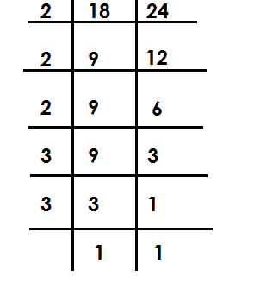

LCM = 2 x 2 x 2 x 3 x 3

= 72

**Example III**

What is the LCM of 20 and 18?

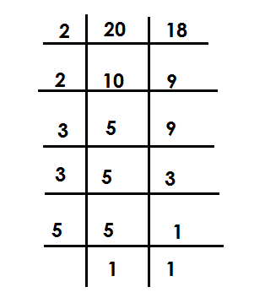 **Soln**

LCM = 2 x 2 x 3 x 5

= 180

Example III

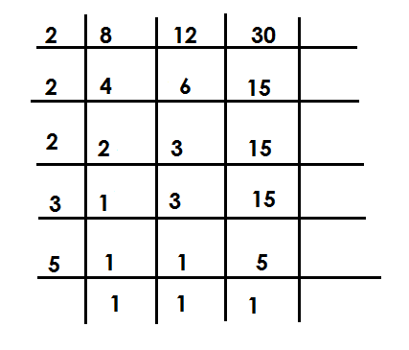Find the LCM of 8 , 12 and 30.

Factorise / divide the three number

using their prime factors.

LCM = 2 x 2 x 2 x 3 x 5

= 120

**Activity**

Find the LCM of the following numbers

1. 8 and 16 7. 60 and 45

2. 12 and 15 8. 9, 12 and 24

3. 9 and 12 9. 12,15 and 20

4. 15 and 24 10. 24, 18 and 30.

5. 30 and 24

6. 32 and 24

**GREATEST COMMON FACTORS**

-A factor is a number that divides a given number exactly.

-GCF is the largest number that can divide the given number exactly.

**FINDING GREATEST COMMON FACTORS (G.C.F / H.C.F / G.C.D)**

**Examples**

Find the GCF of 12 and 18

**Soln**

F12 = { 1 , 2 , 3 , 4 , 6 , 12}

F18 = { 1 , 2 , 3 , 6 , 9 , 18}

GCF = 6

**Example II**

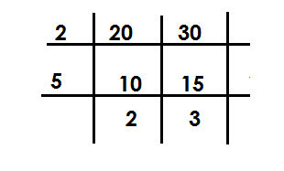Find the GCF of 20 and 30.

Factorise using the numbers that can divide

the given two numbers exactly

GCF = 3 x 5

= 10

**Example III**

Work out the GCF 9 and 12.

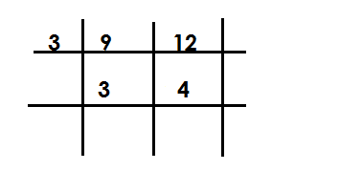**Soln**

GCF = 3

**Example IV**

Find the the LCF of 12 and 8.

**Soln**

**Note:**

**The lowest common factor of any given number is 1.**

F12 = { 1 , 2 , 3 , 4 , 6 , 12 }

F8  = { 1 , 2 , 4 , 8 }

LCF = 1

**Activity**

1. Find the GCF of each pair of numbers.

(a) 12 and 18 (b) 12 and 24 (c)24 and 36 (d) 9 and 21

(e) 34 and 12 (f) 40 and 30 (g) 72 and 96 (h) 33 and 44

(i) 49 and 63

2. Find the L.C.F of (i) 6 and 9

(ii) 12 and 15

(iii) 14 and 21

**TYPES OF NUMBERS**

**WHOLE NUMBERS**

(a) These are positive integers include zero (0).

(b) These are numbers that are not fractions. The first whole number is zero (0)

Examples

{0, 1, 2, 3, 4, 5, 6, 7, 8, ---}

**COUNTING /NATURAL NUMBERS**

These are numbers that show concrete quantity of things

**Note**:

The first counting number is 1

Examples {1, 2, 3, 4, 5, 6, 7 …)

Counting numbers have a pattern of +1 and -1 in ascending and descending orders respectively.

**EVEN NUMBERS**

These are numbers that can be exactly divisible by two. The first even number is zero (0). Example {0, 2, 4, 6, 8, ---}

Even numbers have a pattern of +2 and -2 in ascending and descending orders respectively.

**ODD NUMBERS**

These are numbers when divided by two, give a remainder 1.

The first odd number is one (1)

**Example** {1, 2, 3, 7, 9, …}

Odd numbers have a pattern of +2 and -2 in ascending and descending orders respectively.

**PRIME NUMBERS**

These are numbers with only two factors i.e., one and itself.

The first prime number is 2.

**Note**:

These number have no clear pattern.

Examples {2, 3, 5, 7, 11, 13, 17, …)

**COMPOSITE NUMBERS**

These are numbers with more than two factors.

The first composite number is 4

Examples {4, 6, 8, 9, 10, 12, 14, 15, …)

**TRIANGULAR NUMBERS**

These are numbers got by adding consecutive counting numbers.

The first triangle number is I

Example {1, 3, 6, 10, 15, 21, …}

**FINDING TRIANGULAR NUMBERS**

**Example I**

n =

3( 3+1)

2

6

Find the 3rd triangle number.

**Soln**

3rd No. = 1 + 2 + 3

= 6

**Example II**

What is the 5th triangular number?

**Soln**

5th No. = 1 + 2 + 3 + 4 + 5

= 15

**Example III**

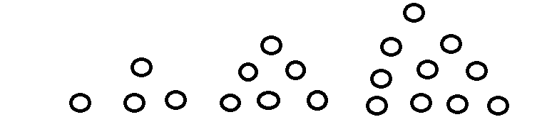Complete the sequence

**Activity**

1. Find the 4th triangular number.

2. What is the sum of the 2nd and 5th triangular number.

3. Find the sum of the next two numbers in the sequence.

1, 3, 6, 10, 15, ________, _______

4. Find the product of the next two numbers in the sequence.

55, 45, 36, 28, _______, ________

**PRIME NUMBERS AND PRIME FACTORISATRION**

**PRIME FACTORISATION**

This is the writing of a number as a product of its prime factors.

Prime factors of a number are represented in two ways;

1. Multiplication form/ Power form
2. Subscript / Set notation form.

**Prime factorising number.**

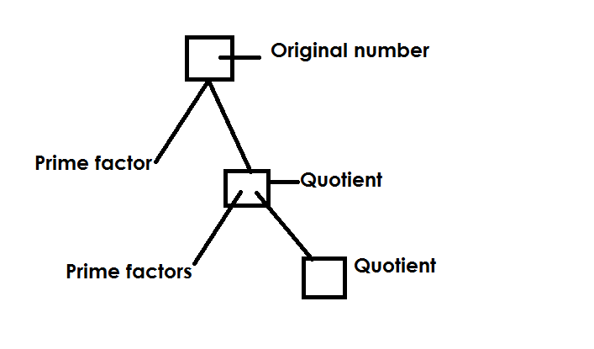**a) Using a factor tree**

**Example I**

Prime factorise 24 and represent the prime factors in

1. Multiplication form
2. Set notation form

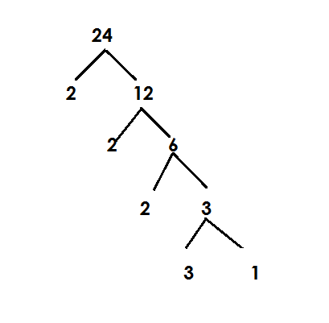 **Soln**

(i) Multiplication form

F12 = 2 x 2 x 2 x 3

Power form / super script form

F24 = (2 x 2 x 2) x 3

= 23 x 31

Set notation / subscript form

F24 = {21, 22, 23, 31}

**Example II**

Prime factorise 72

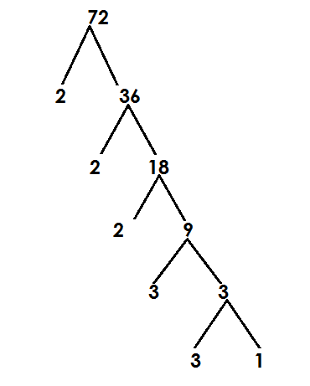(a) Giving your answer in multiplication form.

F72 = 2 x 2 x 2 x 3 x 3

(b) Give your answer in set notation /sub script form.

F12 = (2 x 2 x 2) x (3 x 3)

= 23 x 32

(c) Give your answer in subscript form.

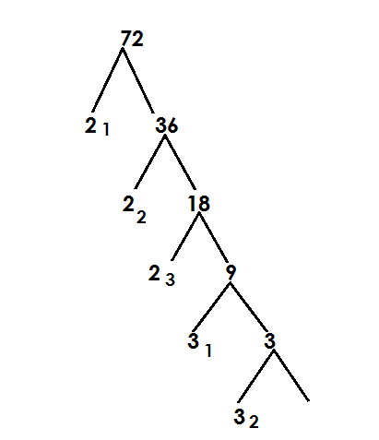

F12 = (21, 22, 23, 31, 32)

**b) Using ladder method**

**Examples**

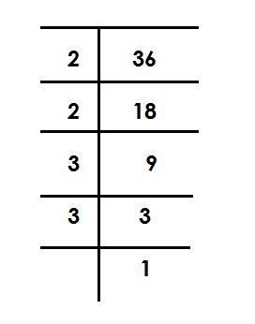1. Prime factorise 36

Multiplication form

= 2 x 2 x 3 x 3

Power form /superscript

= 2 x 2 x 3 x 3

= 22 x 32

Subscript form / set notation

F36 = {21, 22, 31, 32}

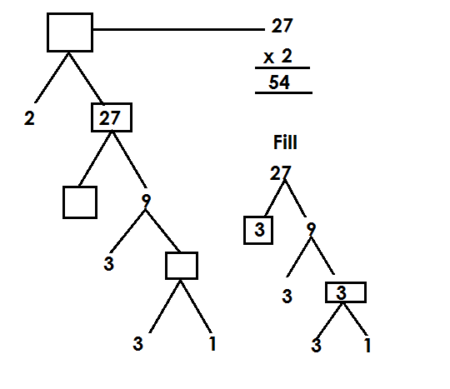2. Fill in the missing numbers

**Activity**

1. Prime factorise each of the following and show your answer in power form.

(a) 18 (b) 40 (c) 30 (d) 45

2. Prime factorise each of the following numbers using set notation/ subscripts.

(a) 10 (b) 20 (c) 60 (d) 49

3. Express the following numbers as a product of their prime factors.

(a) 15 (b) 90 (c) 120 (d) 100

4. Complete the factor tree below.

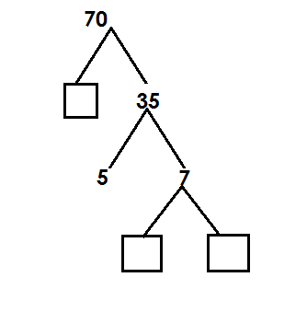

**FINDING THE PRIME FACTORISED NUMBER**

**Examples**

Find the number which is prime factor to give.

= {21, 22, 23, 31}

= (2 x 2) x (2 x 3)

= (4 x 6)

= 24

Find the number whose factorization is 2**2** x 3**2** x 5**1**

= (2 x 2) x (3 x 3) x 5

= 4 x 9 x 5

= 36 x 5

= 180

Which number was prime factorised to give 22 x 52?

= 22 x 52

= 2 x 2 x 5 x 5

= 100

**Activity**

Find the number whose prime factorization are given below.

1. {21, 22, 23)

2. {21, 22, 31, 32}

(c) (22 x 31)

(d) 21 x 32 x 51

(e) 72 x 51

(f) 24 x 31

**REPRESENTING PRIME FACTOR ON A VENN DIAGRAM**

**Examples**

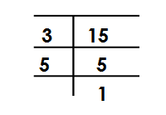Show prime factors of 12 and 15 on venn diagram

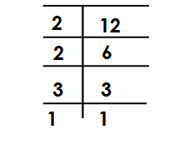 F12 = F15 =

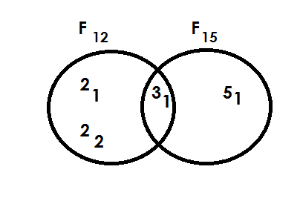 F12 = {21, 22, 31} F15 = {31, 51}

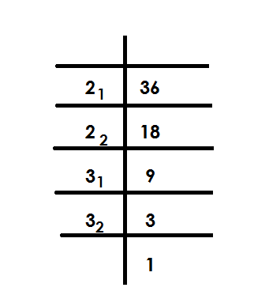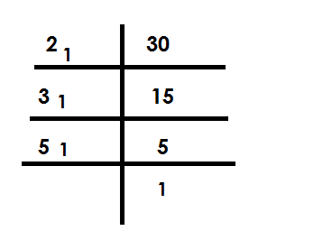Prime factorise 30 and 36 and represent them on a venn diagram.

PF30 = PF36 =

PF30 = {21, 31, 51,}

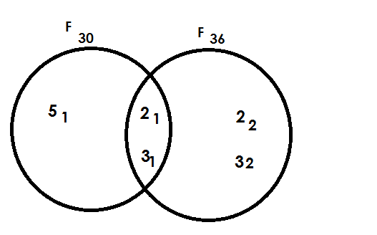

**Activity**

1. Draw venn diagram to represent the prime factors for the following pairs of numbers.

(a)24 and 30. (b)30 and 48 (c)18 and 20. (d) 15 and 20

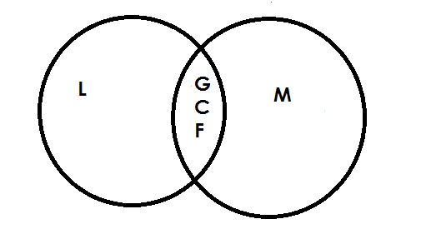 **Find LCM AND G.C.F from a Venn diagram.**

L.C.M = product of intersection

G.C.F = product of union

**Example I**

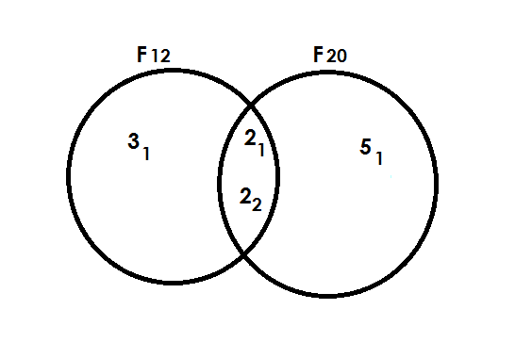Use the venn diagram below to answer question that follow.

Find the G.C.F of F12 and F20

G.C.F = Product of intersection

= 21 x 22

= 2 x 2

= 4

(ii) Find the L.C.M of F12 and F20

L.C.M = Product of union

= 31 x 21 x 22 x 51

= 3 x 2 x 3 x 5

= 6 x 10

= 60

(ii) Find the L.C.M of F12 and F20

L.C.M = Product of Union

= 31 x 21 x 22 x 5

= 3 x 2 x 2 x 5

= 6 x 10

= 60

**Activity**

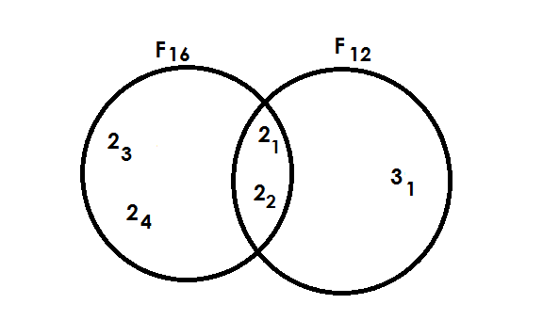1. Study the venn diagram and answer the questions that follow.

(i) Find (i) F16 n F12

(ii) The G.C.F of 16 and 12

(iii) F16 u F12

(iv) L.C.M of F16 and F12

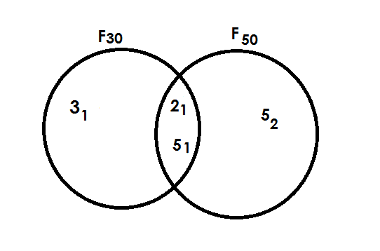2. Study the venn diagram and answer the questions that follow.

(a) Find the G.C.F of 30 and 50.

(b) Find the L.C.M of F30 and 50.

3. Study the venn diagram and answer the questions that follow.

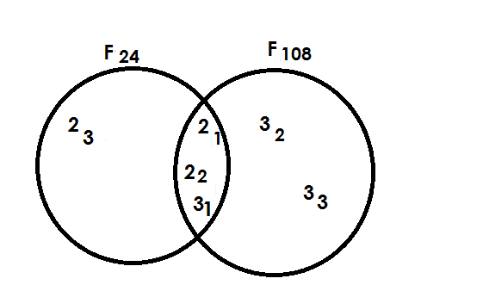

(i) Find F24n F108

(ii) Find the G.C.F of 24 and 108

(iii) Find the L.C.M of 24 and 108

**FINDING UNKNOWNS ON AVENN DIAGRAM**

**Example I**

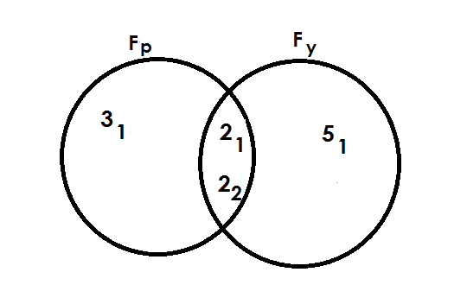1. Use the venn diagram below to answer questions.

Find the value of

(ii) P

P = 31 x 21 x 22

P = 3 x 2 x 2

= 12

(ii) y

Fy = 21 x 22 x 51

= 2 x 2 x 5

= 20

**Example II**

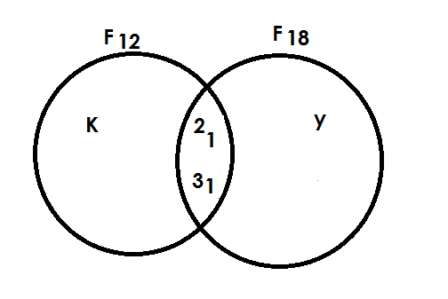2. The venn diagram below shows F12 and F18. Use it to answer question.

Find the value of K.

**Soln**

K + 21 x 31 = 12

K + 21 x 3 = 12

6K = 12

6 = 6

K = 22

Find the value of y.

y x 21 x 31 = 18

y x 21 x 31 = 18

6y = 18

6y = 18 3

6 6

y = 32

**Example III**

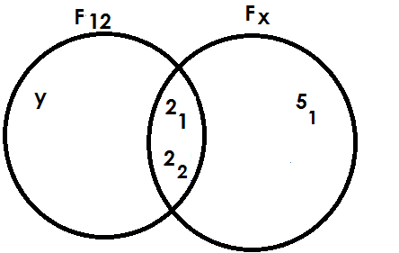3. Below is a venn diagram use I to answer questions.

Find the value of x

x = 21 x 22 x 51

= 2 x 2 x 5

= 20

Find the value of y

y x 21 x 22 = 12

y x 2 x 2 = 12

4y = 12

4y = 12 3

4

y = 31

**Activity**

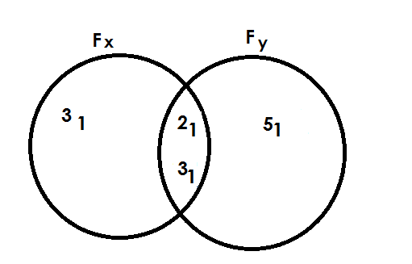1. Study the venn diagrams below and answer the questions.

(a) Find the value of (i) X

(ii) y

(b) Find the G.C.F of x and y.

(c) Find the L.C.M of x and y.

2. Study the venn diagrams below and answer the questions.

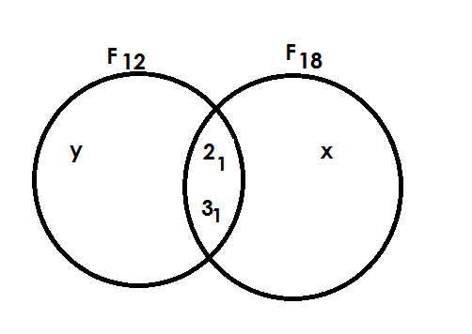

(a) Find the value of (i) X

(b) Find the G.C.F of 12 and 18.

(c) Find the L.C.M of 12 and 18.

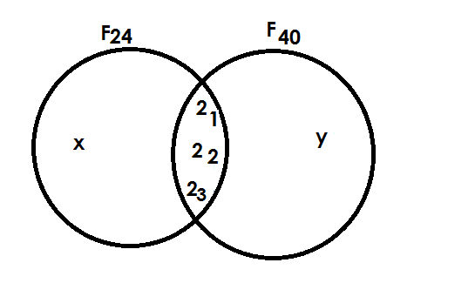3. Study the venn diagrams below and answer the questions.

(a) Find value of (i) m

(ii) n

(c) Find the G.C.F of Fm and 30

(d) Find the L.C.M of Fm and 30

**SQUARE NUMBERS**

Square number is a number got by multiplying a counting number itself twice.

e.g. 2 x 2 = 4

square

**FINDING SQUARE NUMBERS**

Find the square of 2

Soln

22 = 2 x 2

= 4

**Example II**

Find the square of 5

Soln

5**2** = 5 x 5

= 25

Example II

Find the square of n

n2 = n x n

= n2

**Activity**

Find the square of the following numbers.

(a) 6

(b) 7

(c) 8

(d) 10

(e) 12

(f) 13

**FINDING SQUARE ROOTS**

A square root is a number that was multiplied by itself to get a square.

e.g 4 x 4 = 16 square

 square root

A square root symbol is

**Note**:

In findind square root, the following is done;

* First introduce the square root symbol to the given number whose square root is needed.
* Prime factorise the given number.
* Pair the prime factors.
* Pick one factor from each pair.
* Multiply the picked prime factors if more than one. The product got will be the square root.

**Example I**

Find the square root 36.

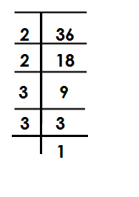

36 = (2 x 2) x (3 x 3)

= 2 x 3

= 6

**Example**

Find the square root of 49

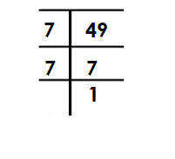 **Soln**

49 =

49 = (7 x 7)

49 = 7

**Example III**

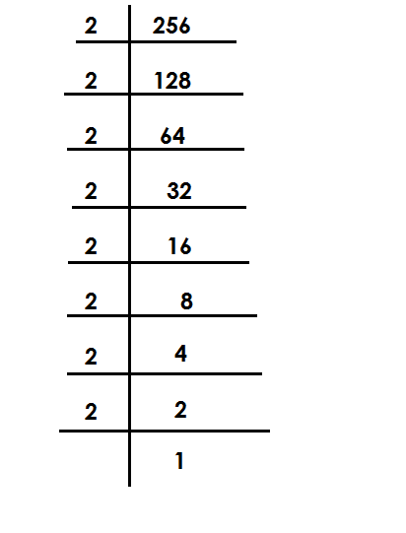Find the square root 256

256 =

256 = (2 x 2) x (2 x 2 ) x ( 2 x 2 ) x ( 2 x 2 )

= (2 x 2) x (2 x 2)

= 4 x 4

= 16

**Activity**

1. Find the square root of the following.

(a) 4

(b) 16

(c) 25

(d) 64

(e) 81

(f) 100

(g) 144

**Application of square root.**

1. What number was multiplied by itself to get 16.

Let the number be m

m x m = 16

m 2  = 16

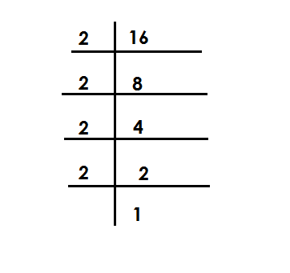 m x m =

m = (2 x 2) x (2 x 2)

m = 2 x 2

m = 4

**Example II**

The area of square is 64cm2. Find length of each side.

**Soln**

Let each side be n

n x n = 64

n2 = 64

n2 = 64

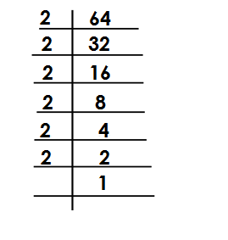

(n x n) =

n = (2 x 2) x (2 x 2 ) x (2 x 2)

n = 2 x 2 x 2

= 8cm

**Activity**

1. The area of a square is 36cm2. Find the length of side.

2. When a number is multiplied by itself the result is 144. Find the number.

3. Area of a square garden below is 400m2.

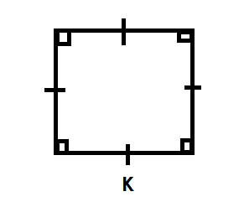

(a) Find the value of K.

(b) Find its perimeter.

4. Find the number that was multiplied by itself to give 81.

5. A square room has an area of 16m2. Find the distance around the room.

**TERM 2 WORK**

**FRACTIONS**

A fraction is part of a whole.

**REVIEW**

* Types of fractions
* Expressing improper fractions as mixed numbers.
* Expressing mixed numbers as improper fractions.
* Equivalent fractions.

**REDUCING FRACTIONS**

Fractions can be reduced using prime factors.

**Example 1**

Reduce 12

24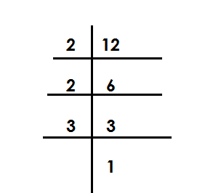

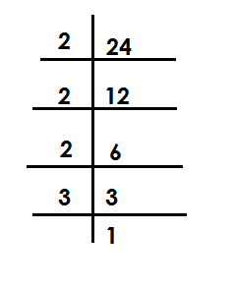 F12  = F24  =

12 = 2 x 2 x 3

24 2 x 2 x 2 x 3

= 1

2

**Example II**

Reduce 75 to its lowest terms.

100

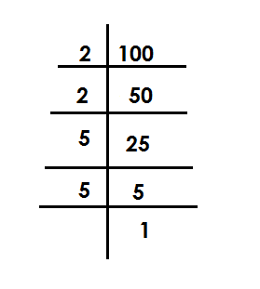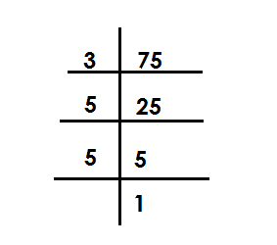 F12 = F100 =

75 = 3 x 5 x 5

100 2 x 2 x 5 x 5

=

**Example III**

Reduce 18 to its lowest terms.

24

**Note**:

Fractions can also be reduced by dividing both numerator and denominator by GCF.

18 = 18 ÷ 6 F18 = {1, 2, 3, 6, 18}

24 = 24 ÷ 6 F24 = {1, 2, 3, 4, 6, 8, 12, 24}

= 3

4

**Activity**

Reduce the following fractions to their lowest forms.

1) 2 2) 8 3) 6 4) 30 5) 32

4 12 18 90 56

6) 24 7) 21 8) 18

72 42 36

**ORDERING FRACTIONS**

**Note**:

- Ascending order means from smallest to biggest.

- Descending order means from biggest to smallest.

- Find the LCM of denominators and the multiply it by all fractions to get their value in whole form.

**Example I**

Arrange the following fractions in ascending order

1, 1, 1

3 2 4

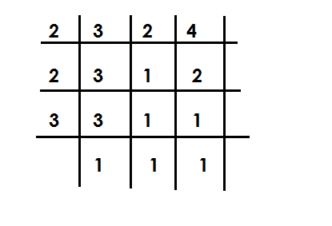 Soln

LCM =

= 2 x 2 x 3

= 12

1 1 1

3 2 4

4 5 3

1 x 12 1 x 10 1 x 12

3 2 4

4 5 3

Ascending order = 1, 1, 1

4 3 2

**Example II**

Arrange the following fraction in a descending order: 5, 7, 3

8 12 8

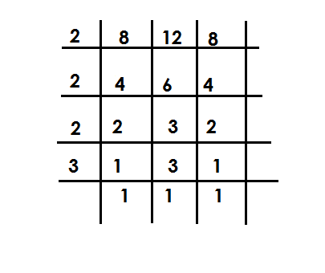 LCM =

LCM = 2 x 2 x 2 x 3

= 24

5 7 3

8 12 8

3 2 3

5 x 24 7 x 24 3 x 24

8 12 8

5 x 3 2 x 7 3 x 3

15 14 9

Descending order = 5 , 7 , 3

8 12 8

**Activity**

1. Arrange the following fractions in ascending order.

(a)  **, ,**

**(b) , ,**

(c) **, , ,**

**(d) , ,**

2) Arrange the following fractions in a desending order

(a)  **, ,**

**(b) , ,**

**(c) , ,**

**(d) , ,**

**ADDITION OF SIMPLE FRACTIONS**

**Note**:

All answers must be in their simplest forms i.e., either a simplifies proper fraction or a mixed number.

Examples Or

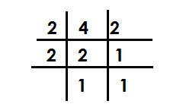Add:  **+**

LCM of the denominators =

= 1 x 2 + 1 x 4

2 x 2 = 4 4 x 2 2 x 4

1 + 1 ( x 12) + ( x 4) = 2 + 4

4 2 12 8 8

= ( 1 x 3 ) + ( 1 x 2) = 6 3

12 8 4

= 1 + 2 = 3 = 3

4 4 4

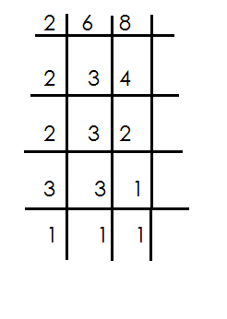**Example II**

Work out: + LCM =

4 3

5 + 3 = 5 x 24 + 3 x 24

6 8 6 8

= (5 x 4) + ( 3 x 3)

24

= 20 + 9

24 2 x 2 x 2 x 3

= 29 1 rem 5 = 24

24

= 1

**Activity**

Add the following fraction.

1.  **+**

2**.**

3. **+**

4. **+**

5. **+**

6. **+**

7. **+**

8. **+**

**ADDITION OF FRACTIONS TO WHOLE NUMBERS**

Examples Example III

**Soln** Add 4 +

3 + 5 **Soln**

4

**Example** II 4 + ( + )

Workout 4

4 + 10 4 + ( x 8)

4 + 10 = (4 + 10) + 4 + (3 + 4)

= 14 + 8

= 14 4 +

4

**Activity**

Workout the following fractions

1. + 8 8. 6 +

2. 4 + 9 9. 1 +

3. 5 + 4

4. + 9

5. 10 + 2

6. 15 + 5

6. 15 + 5

7. 1 +

**ADDITION OF MIXED NUMBERS**

**Note**:

Change the mixed numbers to improper fraction.

Use the LCM approach to work out

**Example I**

Work out: 1 x 3 =(3 x 2) + (13 x 1) = 4

**Soln** 4

1 + 3 = + = 6 + 13

4

2 194 rem 3

= ( x 4) + ( x 4) 4

4

Work out : 1 + 1 + 1 LCM = 12

1 + 1 + 1 = + + = 49 4 rem 1

= 4

6 3 4

=( x 12) + ( x 12) + ( x 12)

12

= (3 x 6) + (5 x 3) + (4 x 4)

12

= 18 + 15 + 16

12

Work out : + 1 +

= + 1 + = + +

5 3

=( x 15) + ( x 15) + ( x 15)

15

=1 + 20 + 9

15

= 3 0 2

15

= 2

**Activity**

Workout the following

1. 3 + 4 7. 2 + 3 + 3

2. 4 + 2 8. 2 + 1 + 1

3. 1 + + 1 9. 3 + 2 +

4. 1 + + 10. + 1 + 4

5. + 5 +

**WORD PROBLEMS INVOLVING ADDITION OF FRACTIONS**

**Example I**

Tom read of the book on Monday and on Tuesday. Find the fraction of the book he read altogether.

Soln

5 2

+ = ( x 10) + ( x 10)

10

= ( 1 x 5 ) + ( 1 x 2 )

10

= 5 + 2

10

= 7

10

**Example II**

A teacher spent an hour giving examples, 1 for exercise and 1 for making. How long was the lesson?

+ 1 +

4 6 3

=( x 12) + ( x 12) + ( x 12)

=( 1 x 4) + ( 3 x 16) + ( 1 x 3)

= 4 + 18 + 3

12

= 25 2 rem 1

12

= 2 hrs

**Activity**

1. Mark filled of a tank with water in the morning and in the afternoon. Find the fraction of the tank that he filled with water.

2. James covered of the journey by bus and by taxi. What fraction of the journey did he cover?

3. Oluku gave 3 cakes to the son and to the daughter. How many cakes did he give out?

4. Mary had 1 sweets, Jane had 2 sweets and Rose had of a sweet. How many sweets did they have altogether?

5. of the wire is painted red, white and blue. How long is the wire?

6. of the land is for grazing, for planting crops and for construction. Find the size of the whole land.

**SUBTRACTION OF SIMPLE FRACTIONS**

**Examples**

Simplify: -

Son

3 - 1 = 3 - 1

8 8 8

= 2 1

8 4

= 1

4

Workout: 1 - 1 **LCM**= 6

2 3

3 2

1 - 1 =( x 6) – ( x 6)

2 3 6

= ( 1 X 3 ) – ( 1 X 2)

6

= 1

6

Simplify 2 - 1 LCM = 10

**Soln**

2 - 1 = - = 7

2 5 10

= ( x 10) – ( x 10)

10

2 5

= ( 11 x 10 ) – ( x 10)

5

=(11 x 2 ) – ( 3 x 5)

10

= 22 - 15

10

**Example IV**

Work out: 5 - 1

Soln LCM = 3

5 - 1 = -

= (5 x 3) – (4 x 3)

1 3

= (5 x 3) – (4 x 1)

3

= 15 - 4

3

= 11 3 rem 2

3

= 3 2

3

**Activity**

Work out the following

(1)  **-**  (8) **3 - 1**

(2)  **-**  (9) **3 - 1**

(3) **-** (10) **6 - 1**

(4)  **-** (11) **8 - 3**

(5)  **-**  (12) **12 - 5**

(6)  **-**

(7) 2  **-**

**WORD PROBLEMS INVOLVING FRACTIONS**

**Examples**

Matama had , what fraction of the sugar cane remained?

**Soln** LCM

Remaining fraction = 4 - 1

6 5 6 = 19

= 4 x 30 - 1 x 30 5 30

5 6

30

= 24 - 5

30

**Example II**

James had 5 cakes, he gave out 2 to mark. How many cakes did he remain with?

**Soln**

**Note**:

- Change mixed to improper

Remaining cakes = 5 - 2

= -

2 3

=16 x 6 - 5 x 6

3 2

6

= ( 16 x 2 ) - ( 5 x 3)

6

= 32 - 15

6

= 17 2 rem 5

6

= 2

**Example III**

My father had 6 plots of land. If he gave out 2 to the children, find the number of plots of land that he remained with.

**Soln** LCM 4

Remaining plots

= 6 - 2

= 6 - 9

1 4

= 6 x 4 - 9 x 4

1 4

4

= 24 - 9

4

= 15 3 rem 2

4

= 3 plots

**Activity**

1. A girl had a glass full of water and used to take medicine. What fraction of water remained in the glass?

2. Moses was given of a sugar cane and he also gave out to his friend. What fraction for the sugar cane did he remain wit?

3. Mukasa had 3 oranges. If he gave out 1 to Peter, find the fraction of the oranges that remained.

4. There were 16 boxes of books in the store, if 8 boxes were given to primary five East class, how many boxes remained in the store?

5. Okello bough 4kg of rice and 2 were used. How many kg of rice remained?

6. After covering of the journey by a taxi, Wandera walked the remaining distance. Find fraction of the remaining distance.

7. Out of the 8 bars of soap that were bought we have so far used 6 . Find the remaining band of soap.

**ADDITION AND SUBTRACTION OF FRACTIONS.**

**Note**:

**Re-arrange the given fraction starting with addition.**

**Example I**

Work out: 1 - 1 + 1

4 2 3

**Soln** LCM = 12

1 - 1 + 1 = 1 + 1 - 1

4 2 3 4 3 2

1 x 12 + 1 x 12 - 1 x 12

4 3 2

12

= ( 1 x 3) + (1 x 4 ) – 6

12

= (3 + 4) - 6

12

= 7 - 6 = 1

12 12

**Example II**

Simplify: 1 - 2 1 + 4 1

4 2 3

**Soln** LCM = 12

1 - 2 1 + 41 = 1 - 5 + 13

4 2 3 3 2 3

= 1 + 13 - 5

4 3 2

3 4 6

= 1 x 12 + 13 x 12 - 5 x 12

4 3 2

= (3 + 52) – 30

12

= 55 - 30

12

= 22 1 rem 10

12

= 1

**= 1**

**ACTIVITY**

**Workout the following**

1.  **- +**

**2. - +**

**3. + -**

**4. + -**

**5. + -**

**6. - 1 + 7**

**7. 2 + 3 + 2**

**8. - 4 + 6**

**MULTIPLICATION OF WHOLES AND FRACTIONS**

Examples

Simplify: 1 x 12 Examples

2

Soln 2. Shade of the figure below

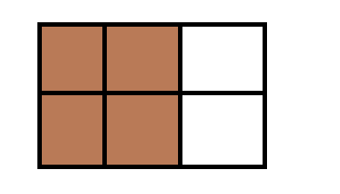1 x 12 = 1 x 12 6

2 2 **Soln**

= 1 x 6 = 2 x 6 parts

= 6 3

= 4 parts

**Example II**

Simplify: 1 x 10

3

**Soln**

1 x 10 = 1 x 10

3 3

= 10 3 rem 1

3

= 3

**Examples III**

Work out: 2 x 24

3

**Soln**

2 x 24 = 2 x 24 8

3 3

= 2 x 8

= 16

**Example IV**

Simplify: 2 x 6

7

2 x 6 = 2 x 6

7 7

= 12 1 rem 5

7

**Activity**

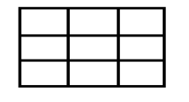Simplify the following

1. 1 x 3 10. Shade 2 of

3 9

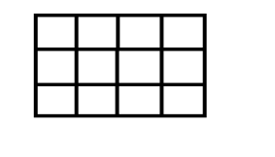2. 2 x 15 11. Shade 3

3 4

3. 6 x 2

3

4. 1 x 12

4

5. 5 x 36

6

6. 4 x 18

9

7. 1 x 8

3

8. 3 x 9

4

9. 2 x 9

5

**MULTIPLICATION OF FRACTIONS BY FRACTIONS**

**Note**:

Multiply numerator by numerator and denominator by denominator.

**Examples.**

Simplify: 1 x 1

3 4

1 x 1

3 4

1 x 1

3 x 4

1

12

**Example II**

Simplify: 2 x 5

3 6

2 x 5 = 2 x 5

6 3 6 3

= 5

9

**Activity**

Simplify the following

1. **x**

**5. x**

**2. x**

**6. x**

**3. x**

**7. x**

**4. x**

**8. x**

**MULITIPLICATION OF MIXED NUMBERS**

**Note**:

-Change mixed number to improve fractions then multiple numerator by numerator and denominator by denominator.

Example 1

Simplify: 1 x

**Soln**

**1 x**

**= x**

**=**

**Example II**

Simplify 5 x 3

**Soln**

5 **x 3 = x**

**2**

**= x**

**= 11 rem 1**

**52**

**3**

**= 17**

**Activity**

Simplify the following

1. 1 x 1 2.1 x 3.1 x 4. 1 x 1

5. 1 x 2 6. 2 x 1

**MULTIPLICATION OF FRACTIONS USING “OF”**

**NOTE:**

The word of can be replaced by X a multiplication symbol (X)

**Example I**

Simplify:1 of 16

2

1 of 16 = 1 x 16 8

2 2

= 1 x 8

= 8

**Example II**

Simplify: 2 of 10

3

**Soln**

2 of 10 = 2 x 10

3 3

= 2 x 10

3

= 20 6rem 2

3

= 6

**Example III**

What is 2 of 5

3 6

Soln

2 of 5= 2 x 5

3 6 3 6

= 2 x 5

3 x 6 3

= 1 x 5

3 x 3

= 5

9

**Example IV**

Simplify: 4 of 30

**Soln**

4 of 30 = 29 x 30

6

= 29 x 30 5

6

= 145

**Activity**

Simplify the following

(1) of 30 (2) of 12 (3)2of 24

(4)of (5) of (6) of

(7)1 of 3 (8) 2 of 3(9) 1 of 3

**APPLICATION OF MULTIPLICATION OF FRACTIONS**

**Example 1**

What is of an hour

Soln

**NB**: Change 1 hr to minutes

1 hour = 60min

= of 60 minutes

of 1 hour = x 60 minutes

= 1 x 60 15

4 1

= 15 minutes

**Example II**

What is of 18

Soln

2 of 18 = 2 x 18 6 = 2 x 6

3 3 1 = 12

**Example III**

A man spent of his salary on food, if his salary was sh.120,000. How much did he spend on food?

**Food** = 3 x sh 120,000

4

= 3 x sh120,000

4

= sh 3 x 30000

= sh 90,000

**Activity**

1. What is of 24 kg?

2. What is of sh 400?

3. Find of 1 kg.

4. Tom read of his book that contains 500 pages, how many pages did he read?

5. Mandela covered of 280km by a taxi, how many km did he cover by a taxi?

6. In a village of 1800 people of them are children, how many children are on the village?

7. of my salary is spent on rent. If my salary is sh200,000, how much do I spend on rent

**FINDING RECIPROCALS / MULTIPLICATIVE INVERSE**

A reciprocal is fraction that when multiplied by a given number the result in one (1)

**Example 1**

Find the reciprocal of

**Soln**

Let the reciprocal be K

2 x K = 1

2K = 1 **OR**

3

2Kx3 = 1x 3 Reciprocal = 1 ÷ 2

3 3

2K =3 = 1 x

2K = 3

2 2 =

K = 3

2

The reciprocal of is

**Example II**

Find the reciprocal of 2

Soln

Let the reciprocal be K

2 x K = 1 7K = 3

K = 1 7K = 3

K = 1 x 3 7 = 7

K = 3

7

**Example III**

What is the reciprocal of 5?

Let the reciprocal be P

5 x P = 1

5P = 1

5P = 1

5P 5

P = 1

5

Example IV

Find the reciprocal of 0.6

Let the reciprocal be y

0.6 x y = 1

6 x y = 1

10

6y = 1

10

6y x 10 = 1 x 10

10

6y = 10

6y = 10

6 1 6

Y = 10

6

**Activity**

Find the reciprocal of the following.

(1) (4) 2 (7) 4 (10) 0.3

(2) (5) 3 (8) 12 (11) 1.4

(3) (6) 4 (9) 7 (12) 0.9

**DIVISION OF FRACTIONS BY WHOLES AND WHOLES BY FRACTIONS.**

**Steps to take:**

Maintain the first fraction, change the division sign to multiplication sign then reciprocate the second fraction.

**Example I**

Work out: 2 ÷ 2

3

**Soln**

= 2 ÷ 2

3 1

= 2 x 1

3 2

= 1 x 1

3 x 1

= 1

3

**Example II**

Simplify: 3 ÷ 35

3 ½ ÷ 35 = ÷

=  **x**

= 1 x 1

2 x 5

= 1

10

**Example III**

Simplify: 6 ÷1

4

**Soln**

6 ÷ 1 = 6 ÷ 1

4

= 6 x 4

1 x 1

= 24

**Example IV**

Divide: 8 ÷ 2

**Soln**

8 ÷ 2

= 8 ÷ 5

2

= 8 x 2

1 5

= 16 3 rem 1

5

= 3 1

5

**Activity**

Work out the following

1. **÷ 2**

1. **4 ÷**
2. **÷ 3**

1. **16 ÷**
2. **÷ 3**

1. **9 ÷**

**DIVISION OF WHOLES AND BY FRACTIONS USING REPEATED ADDITION.**

**Example**

Divide 2 ÷ 1 using repeated addition.

4

**Step1**

Find the equivalent fraction of 2 whose denominator is 4.

2 x 4

1 x 4

= 8

4

**Step2**

Divide using repeated subtraction

2 ÷ 1 8 ÷ 1

4 4 4

**- =**  1st

**- =**  2nd

**- =**  3rd

**- =**  4th

**- =**  5th

**- =** 6th

**- =**  7th

**-**  = 0 8th

2 ÷ = 8

**Activity.**

Work out the following using repeated subtraction

(i) 1 ÷

(ii) 5 ÷

(iii) 2 ÷

**DIVISION OF WHOLES AND BY FRACTIONS USING A NUMBERLINE.**

**Example.**

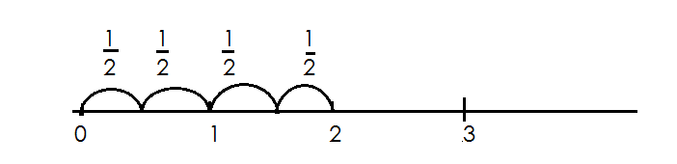Divide2 ÷ using a numberline.

2 ÷ = 4

**Activity.**

(c) Work out the following using a number line

(a) 2 ÷ (b) 8 ÷ (c) 2 ÷

**Division of fraction by fractions**

**Example**

Divide: ÷

**Soln**

÷ = x

= 1 x 4

3 x 1

= 4 1rem 1

3

= 1

**Example II**

Simplify: ÷

=  ***÷***

***=***

= 6

**Example II**

Simplify: ÷ 2

**Soln.**

= ÷ 2

= x

=

**Example IV**

Simplify: 2 ÷ 3

**Soln**

=  **+**

=  **+**

=  **x**

=

**Activity.**

Work out the following

**(1) ÷ (4) ÷ (7) ÷ 4**

**(2) ÷ (5) ÷ 2 (8) 2 ÷ 1**

**(3) ÷ (6) ÷ 2 (9) 2 ÷ 1**

**(10) 2 ÷**

**APPLICATION OF FRACTIONS INVOLVING DIVISION**

**Example I**

How many Chapatis can be got from 2 Chapati?

= 2 ÷

=  **÷**

=  **÷**

=  **x**

= 6

**Example II**

How many litre bottles of milk can be get from 1 litres

No. of bottle = 4 ÷

=  **÷**

=  **x**

=  **x 2**

= 18 bottles

**Example III**

How many small packets of 1 kg can be got from a sack of 9kg?

No. of packets = 9 ÷ 1

= ÷

= x

= 7rem 1

= 7 packets

**Activity**

1) How many cakes be got from 3 cakes?

2) If we use kg of sugar per day, how many days shall we use 12 kg.

3) How many litre bottle can get got forty litre jerry can?

4) A farmer has 7 hectares of land, to be divided into plots of 1 hectares, how many plots will he get?

5) A bag contains 5 kg of maize. Find to be number of kg packets that will be obtained.

6) A woman has 13 kg of sugar. How many packets each kg does she have?

7) 12 litres of milk were given to child if each get litre of milk, how many

children were server altogether?

**DECIMAL FRACTIONS**

* Decimals are fraction whose denomitors are multiples of ten.
* A decimal number is a number with a decimal point separating whole numbers and fractions.
* To the left of a decimal point, there are whole numbers and to the right, there are decimal number. (fractions)
* Decimal places are the number of digits after a decimal point.

**CHANGING COMMON FRACTIONS TO DECIMAL FRACTIONS**

**(A) Without multiples of ten as denominators.**

**Examples**

Change to a decimal fraction

**Soln**

= 0. 5

2 1 0

- 1 0

0 0

= 0.5

Change to decimal fraction

= 2 ÷ 5

0.4

5 20

4 x 5 = 20

= 0.4

Change to a decimal.

0.75

= 4 3 0

2 8

- 2 0

5 x 4 2 0

= 0.75

**Activity**

Express the following fractions as decimals

(a) (b) (c) (d) (e) (f) (g)

**(B) Given multiples of 10 as denominator**

The number of zeros “0” of the denominator in a common fraction is equal to the number of decimal places.

**Examples**

Express the following as decimals

(a) = 0.1 (one zero, one decimal place)

(b) = 2.5 (one zero, one decimal place)

(c) = 0.25 (two zeros, 2 decimal places)

(d) = 0.625 (3 zeros, 3 decimal places)

(e) = 0.003 (3 zeros, 3 decimal places)

**Activity**

Express these as decimal fractions

(a) (b) (c) (d)

(e) (f) (g)

**CHANGING DECIMALS TO COMMON FRACTION**

**Example I**

(a) 0.5 = (1 decimal 1 zero)

(b) 0.0.5 = (2 decimal 2 zero)

(c) 0.003 = (3 decimal 3 zeros)

**Example II**

(a) 6.9 =

= 6

(b) 6.09

= 609

100

= 609

100

(c) 8.625 = 8625

1000

= 8

**Activity**

Express the following decimals as fractions.

(a) 0.1 (e) 14.9 (i) 9.09

(b) 0.001 (f) 49.8

(c) 0.25 (g) 3.78

(d) 9.08 (h) 9.008

**CHANGING MIXED FRACTIONS TO DECIMALS**

**Examples**

(a) 3 = (10 x 3) + 1 (b) 7 = (100 x 7) + 5

10 100

= 30 + 1 = 700 + 5

10 100

= 31 = 705

10 100

= 3.1 = 7.05

(c) 9 = (1000 x 9) + 75 (d) 7 = (1000 x 7) + 5

100 1000

= 9000 +75 = 7005

100 1000

= 9075 = 7.005 100

= 90.75

**Activity**

Express these mixed fractions as decimals fractions.

(a) 9

(b) 7

(c) 3

(d) 3

(e) 7

(f) 4

**Comparing decimals using symbols**

Use >, < or = to complete the following statements.

(a) 0.2 0.5

**Soln**

 0.2 0.5

2 5

10 10

2 x 10 5 x 10

10 10

(b) 0.4 0.25

**Soln**

 4 25

10 100

4 x 100 25 x 100

10 100

40 25

(c) 0.5 0.15

**Soln**

 0.5 0.15

10 100

5 x 100 15

10 100

50 15

**Activity**

**Use >< or = complete**

(a) 0.2 0.9

(b) 3.2 2.5

(c) 0.5 0.05

(d) 4.5 4.05

(e) 20.5 2.05

(f) 40.3 44.3

**ORDERING DECIMALS IN ASENDING AND DESCENDING**

**Note**:

* Change decimals to common fractions.
* Find the LCM of all denominators.
* Multiply each fraction by LCM
* Take the biggest denominator to the LCM

**Examples**

1. Arrange the following fraction in ascending order 0.22, 0.2, 1.2

Change to simple fraction = 22, 2, 12

100 10 10

LCM = 100

|  |  |  |
| --- | --- | --- |
| 0.22 | 0.2 | 1.2 |
| x 100  = 22 (2nd) | = x 100  = 20 (3rd) | = x 100  = 120 (1st) |

Required order = 0.2, 0.22, 1.2

2. Arrange the following fraction in descending order.0.1, 1.1, 0.11

LCM = 100

|  |  |  |
| --- | --- | --- |
| 0.1  1 x 100  100  10 | 1.1  11 x 100  10  110 | 0.11  11 x 100  100  11 |
| 3rd | 1st | 2nd |

The order = 1.1, 0.11, 0.1

3. Arrange from the biggest 0.22, 0.2, 0.202

LCM = 1000

|  |  |  |
| --- | --- | --- |
| 0.22  22  100  22 x 1000  100  = 220 | 0.2  2  10  2 x 1000  10  = 200 | 0.202  202  1000  202 x 1000  1000  = 202 |
| 1st | 3rd | 2nd |

Required order = 220, 202, 200

**Activity**

1. **Arrange the following fractions in ascending order**

(a) 0.1, 03, 0.33

(b) 0.8, 8.08, 0.88

(c) 3.4, 0.34, 3.04

(d) 0.9, 0.09, 9,9

2. **Arrange the following fraction in descending order**

(a) 0.3, 0.07, 0.15

(b) 7.7, 0.77, 0.11

(c) 0.404, 0.044, 0.11

(d) 0.1, 303, 0.33

**ADDITION OF DECIMAL FRACTIONS.**

**Note**

-Arrange vertically according to place values.

-Place the decimal points in line

**Examples**

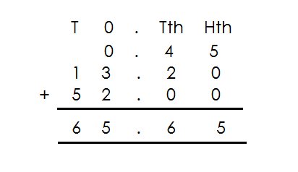1. Add: 0. 4 5 + 1 3. 2 + 5 2. 0 0

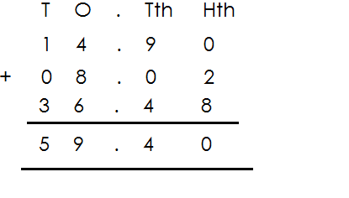2. Add: 1 4. 9 + 8. 0 2 + 3 6. 4 8

**ACTIVITY**

**Add the following**

1. 4.96 + 1.7 + 0.36

2. 0.58 + 5.8 + 58.00

3. 0.22 + 2.22 + 22.22

4. 2.76 + 3.85 + 1.09

5. 65.6 + 4.5 + 20.8

6. 0.35 + 12.2 + 51.0

7. 2.7 + 8.92 + 0.37

8. 0.45 + 1.32 + 52.00

**SUBTRACTION OF DECIMALS**

**Examples**

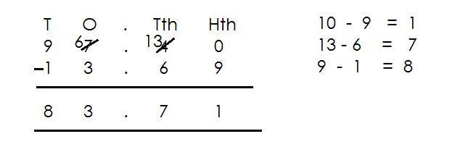1. Subtract: 97.4 - 13.69

2. Subtract: 97. 4 - 13.69

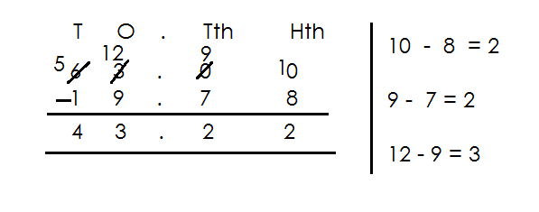

3. Subtract: 97.4 – 13.69

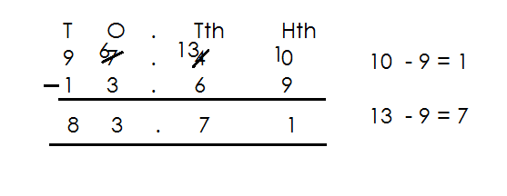

**Activity**

(a) 73 - 19.5 (e) 50. 12 – 17.48

(b) 12 – 9.5 (f) 8.54 – 2.34

(c) 57.9 – 3.51 (g) 14.9 – 3.51

(d) 7.2 - 5.36 (h) 166 – 66.9

**ADDITION AND SUBSTRACTION OF DECIMAL FRACTIONS**

**Note:**

* First re-arrange by adding first then subtract.
* A number takes a sign before it.

**Example**

1. Work out 13.75 – 27 + 91.25

13.75 – 27 + 91.25

T O th Hth T O Tth Hth T O

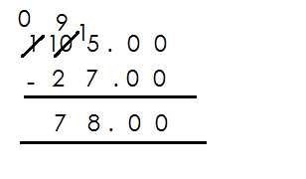 (1 3. 7 5 + 9 1. 2 5) – 2 7

2. Work out 4.000 - 2.625 + 33.000

(4.000 + 33.000) – 2.625

O Tth Hth Thth T O Th HthThth O Tth Hth Thth

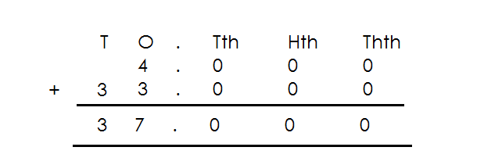 4. 0 0 0 + 3 3. 0 0 0 - 2 . 6 2 5

**Activity**

**Work out the following**

1. 35.1 - 44. 3 + 17.6

2. 8.24 + 22.9 – 78

3. 2.76 + 1.69 – 2.85

4. 7.982 – 9.082 + 4.007

5. 5.625 – 8 + 4.375

6. 23.7 – 65.9 + 82.6

7. 12 – 0.75 + 0.75

8. 65.6 - 45.9 + 0.36

**MULTIPLICATION OF DECIMAL FRACTION BY 10, 100 AND 1000**

**Note:**

-Change the decimals to common fractions then multiply by 10, 100, 1000.

**Examples**

1. Multiply 6.25 x 10 3. Multiply 6.25 x 1000

x 10 = x 1000

= 62. 5 = 625 x 10

10

= 62.5 = 6250

2. Multiply 6.25 x 100 4. Multiply 7.425 x 10

Soln Soln

x 100 x 10

= 625 =

= 74.25

5. Multiply 7.425 x 100 6. Multiply 4.325 x 1000

7.425 x 100 4325 x 1000

74.25 x 100 1000

1000

 = 742.5 = 4325

= 742.5

**ACTIVITY**

Multiply the following

1. 0.12 x 10

2. 15.6 x 10

3. 13.489 x 10

4. 15.6 x 100

5. 9.46 x 100

6. 0.875 x 100

7. 30.729 x 100

8. 0.125 x 1000

**MULTIPLICATION OF DECIMAL BY A DECIMAL.**

**NOTE:** First change decimals to common fractions before multiplying.

1. Multiply 2.3 x 0.2 3. Multiply 0.018 x 0.4

**Soln Soln**

23 x 2 = 18 x 4

10 10 1000 x10

= 23x 2 = 18 x 4

10 x 10 1000 x10

= 46 = 72

100 10000

= 0.46 = 0.0072

2. Work out 3.75 x 2.4

**Soln**

3.75 x 2.4

= 375 x 24

100 x 10

= 375 x 24

100 x 10

= 9000

1000

= 9

**Activity**

Multiply the following

1. 0.6 x 0.06

2. 0.2 x 0.03

3. 2 x 05

4. 3.02 x 0.9

5. 7.2 x 8

6. 0.8 x 24

7. 2.5 x 2.5

8. 0.03 x 0.3

9. 3.6 x 0.11

**LINES,ANGLES AND GEOMETRIC SHAPES**

**Parallel lines**

These are lines which do not meet because they are of the same distance apart.

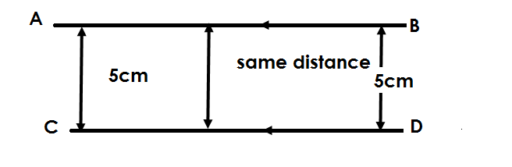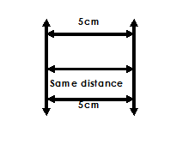 **Example I** **Example II**

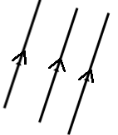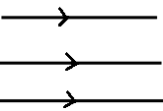To show that the given lines are parallel we use signs as shows below.

**Activities**

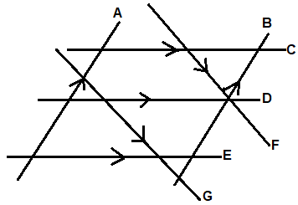Which of the lines above are parallel lines?

**Drawing parallel lines**

**1. Using a ruler**

Place a ruler on the paper, then draw a line on each side of the ruler.

2. **Using a ruler and a set square**

**Procedure**

**Step I**

Draw a line AB and mark point P where the other parallel line shall pass

**Drawing and identifying perpendicular lines**

Perpendicular lines are lines which meet at an angle of 900.

**Note**:

When perpendicular lines meet, they make a square corner called a right angle.

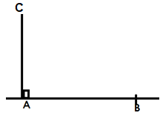The symbol for perpendicular.

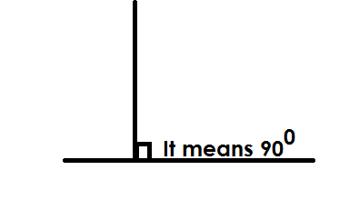

**Drawing perpendicular lines**

Procedure

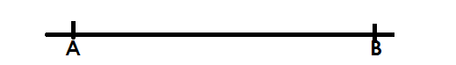-Use a ruler and a set square.

**Step I**

1. Draw a horizontal line.

**Step II**

Place a 600- set square at A as shown in (a) below.

**Step III**

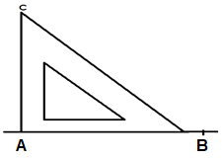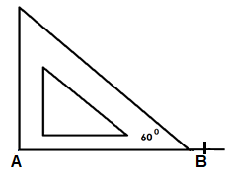Draw a line from A to C using a pencil as in (b) below.

(a)

Step 4

Remove the set square and your lines will look like this.

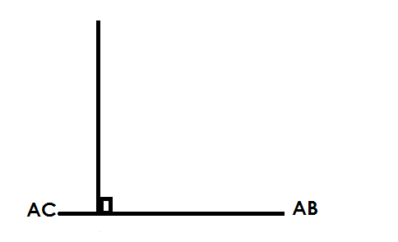

Therefore, Ac is perpendicular to AB

**Activity**

Draw a perpendicular line at the point shown using a pencil and a set square.

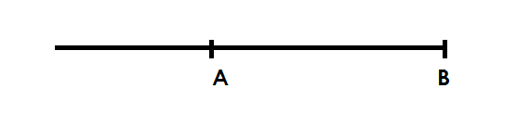1.

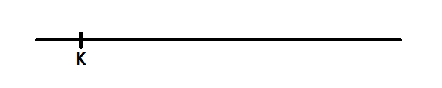

2.

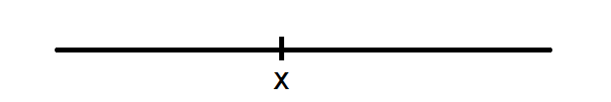

3.

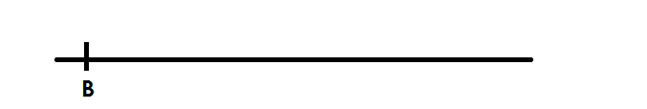

4.

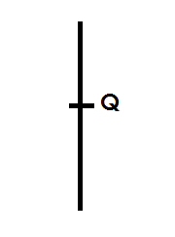

5.

**TYPES OF ANGLES**

An angle is the amount of turning between two straight lines at a fixed point.

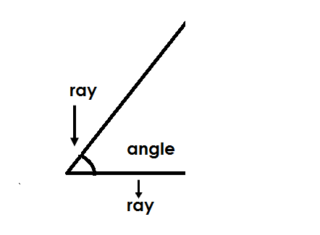Illustration.

**Types of angles.**

**1) Acute angle**

This is an angle which is less than 900

The smallest acute angle is 1**0** and the largest is 89**0**.

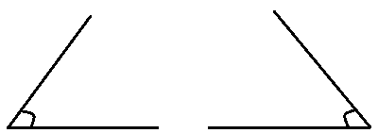**Illustration.**

**2)** **Right angle**

This is an angle which measures exactly 900.

**Illustration.**

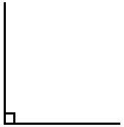

**Finding un known angles in a right angle**

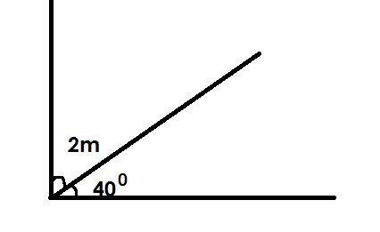Find the value of m.

2m + 400 + = 900

2m + 400 – 400 = 900 – 400

2m =500

2m = 50025

2 2

m = 250

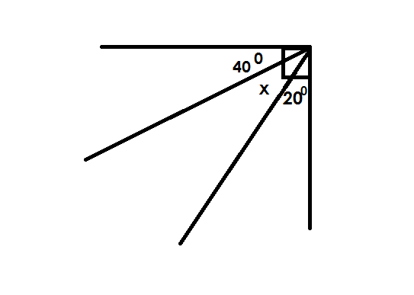Find the value of K in the diagram below.

K + 400 + 200 = 900

K + 600  = 900

K + 600 - 600 = 900 - 600

K = 300

**Activity**

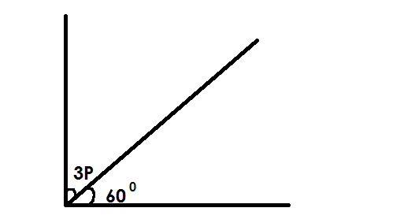Find the value of unknowns in the following

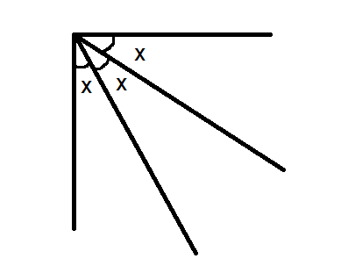(1) (4)

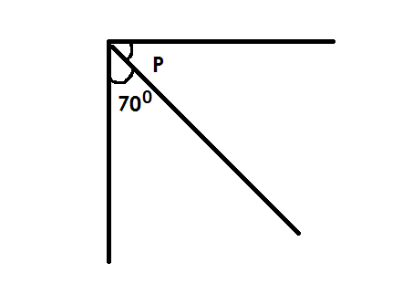

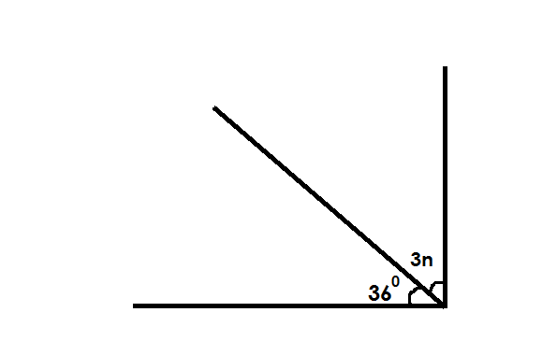(2) (5)

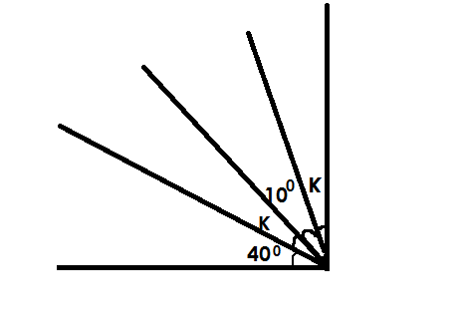

(3) (6)

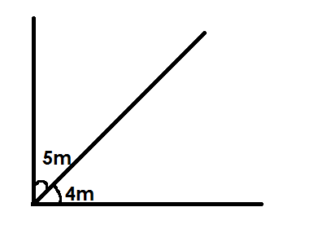

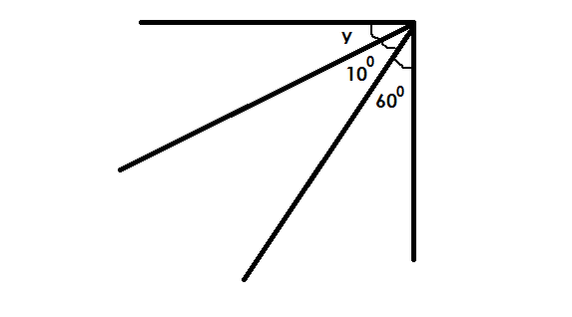(4)

**3) Obtuse angle**

This is an angle great that measures above 900 but less than 1800.

The smallest obtuse angle is 91**0** and the largest is 179**0**.

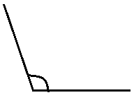**Illustration.**

**4) Straight line angle**

This is an angle which measures exactly 1800.

**Illustration.**







**Finding the un known angles on a straight line**

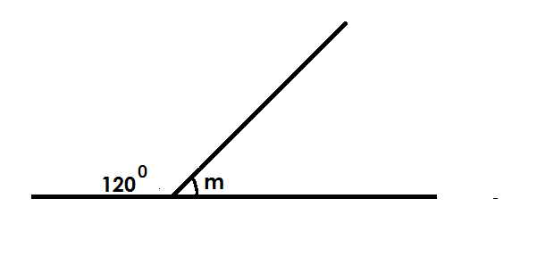Find the value of m

m + 1200  = 1800

m + 1200 - 1200  = 1800 (supp < s)

m = 600

Find the value of x in the figure below.

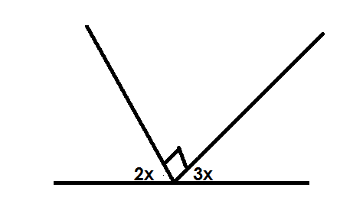

2x + 3x + 900 = 1800 (supp <s)

5x + 900 = 1800

5x + 900 - 900 = 1800 - 900

5x = 90**0**

5 5

x = 180

Find the value of K

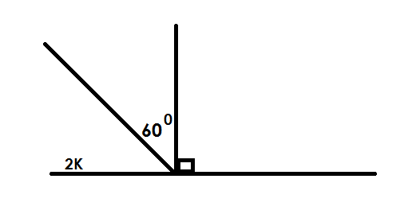

2K + 600 + 900 = 1800 (supp<s)

2K + 1500 = 1800

2K + 1500 - 1500 = 1800 – 1500

2K = 30**0** 15

2 2

K = 15

Find the value of n

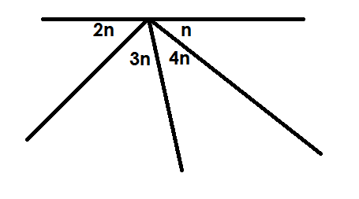

2n + 3n + 4n + n = 180 (supp<s)

10n = 1800

10n = 1800

10 10

n = 180

Three angles n, 700, and 800 are supplementary angles. Find the value of n.

n + 700 + 800 = 1800

n + 1500 = 1800

n + 1500 – 1500 = 1800 – 1500

n = 300

**Activity**

1. Find the value of m

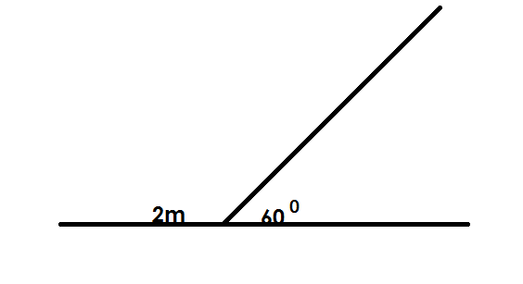

2. Find the value of the unknown angles

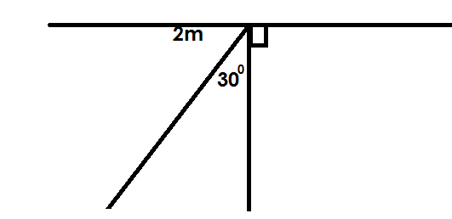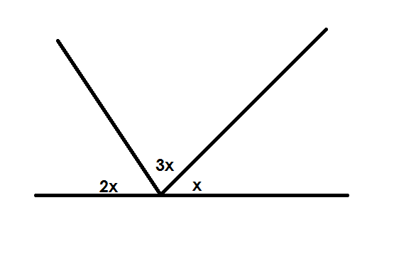(a) (b)

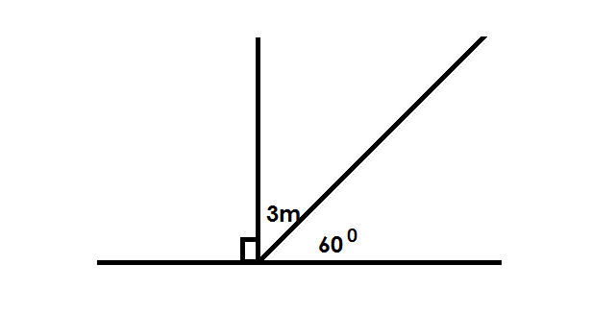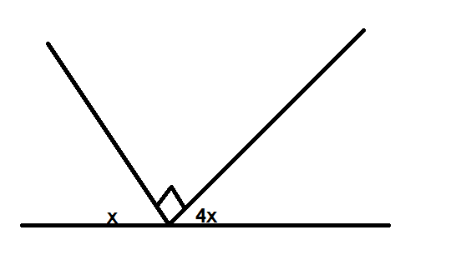(c) (d)

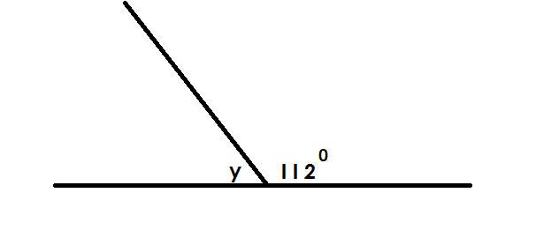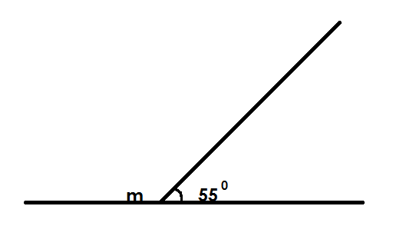

(e) (f)

**5) Reflex angle**

This is an angle greater than 1800 but less that 3600.

The smallest reflex angle is 181**0** and the largest is 359**0**.

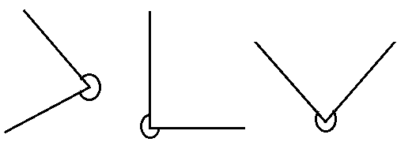**Illustration.**

**6) Centre angles (revolution)**

This is an angle which measures exactly 3600

**Illustration.**

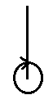

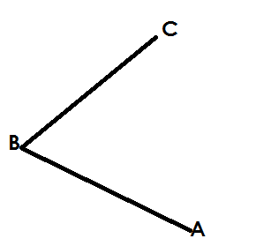**MEASURING DIFFERENT ANGLES USING APROTRACTOR**

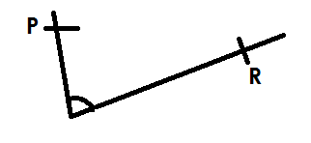(a) (b)

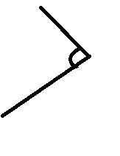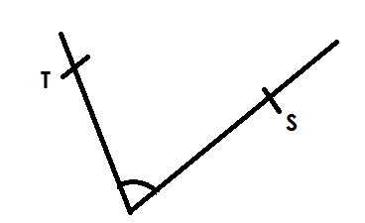

(c) (d)

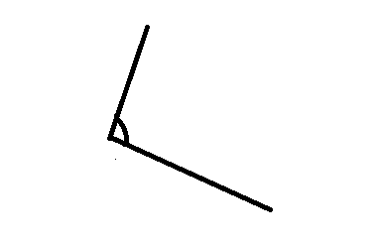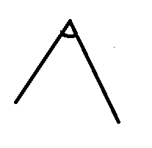

(e) (f)

**DRAWING DIFFERENT ANGLES USING A PROTRACTOR**

**Using a ruler pencil and protractor draw the following angles**.

(a) 600 (b) 500 (c) 750

(d) 1200 (e) 1350

**DRAWING DIFFERENT ANGLES USING A RULER AND PAIR OF COMPASSES ONLY**

Using a ruler and pair of compasses only, construct the following angles.

1. 600 (b) 900 (c) 450  (d) 1200

**CONSTRUCTING AND EQUILATERAL TRIANGLE IN A CIRCLE GIVEN RADIUS.**

**Procedures**

- Mark a point. Using a given radius, draw a circle from the point drawn.

- Make equidistant arcs on the circumference using the given radius.

- Join the arcs by skipping one at a time to draw the equilateral triangle.

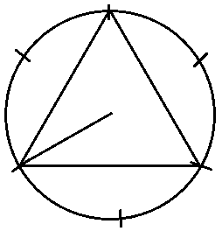

**Activity**

1. Construct an equilateral triangle in a circle given the following radii.

(a) 6cm

(b) 4cm

(c) 5.5cm

(d) 4.8cm

**CONSTRUCTING AN EQUILATERAL TRIANGLE GIVEN SIDES**

**Procedures**

* Draw a sketch
* Draw a base line of the given length.
* The using the same length, draw arcs and join to make an equilateral triangle.

**Example**

Using a ruler and pair of compasses only, construct and equilateral triangle ABC of side. 6cm.

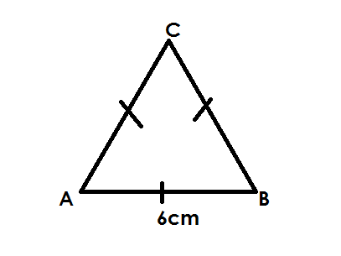**Sketch**

**Accurate drawing**

* Measure and draw a line AB of 6cm.
* Press the compass needle of the compass at either point A or B using the same length of 6cm to draw line / side AC or BC = 6cm.
* Then join the three sides to form an equilateral triangle ABC of sides 6cm.

**Activity**

1. Using a ruler and pair of compasses only construct.

(a) An equatorial triangle PQR of sides 5cm.

(b) An equilateral triangle TNs of sides 4.8cm.

(c) An equilateral triangle ABC of sides 4.50cm.

(d) An equilateral triangle XYZ of sides 5.3cm.

**CONSTRUCTING A REGULAR HEXAGON**

A regular hexagon is a polygon with all its 6 sides equal and its interior angles also equal.

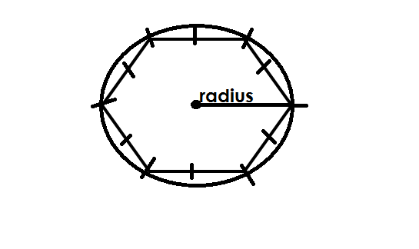**Sketch**

**Procedures**

- Draw a point.

- Using the given radius roll the compass from point to make the circle.

- Cut off equal arcs on the circumference using the given radius.

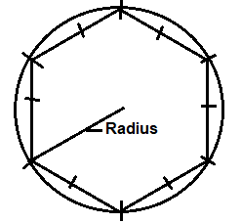- Join all the points on the circumference to make the polygon.

**Activity**

1. Using a ruler and a pair of compasses only, construct aregular hexagon with the following sides.

(a) 4cm

(b) 4.8cm

(c) 5cm

(d) 6cm

**LINES OF FOLDING SYMMETRY**

**Definition**

Is a line that divides a figure into 2 equal parts, which cover each other completely.

A figure is said to be symmetric if it has atleast one line of symmetry.

**LINES OF SYMMETRY IN DFIFFERENT SHAPES.**

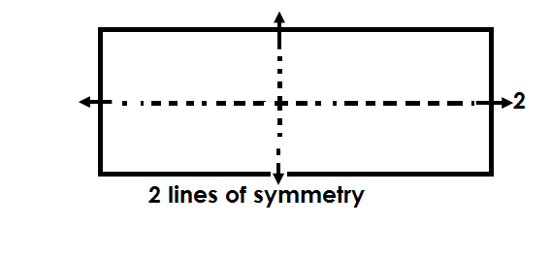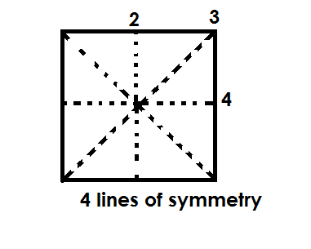(a) Square (b) Rectangle

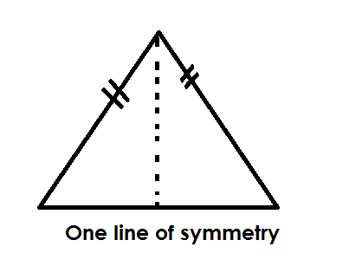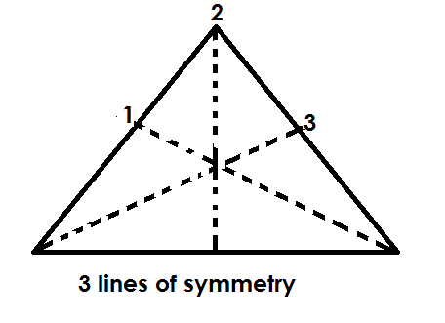(c) Equilateral triangle (d) Isosceles triangle

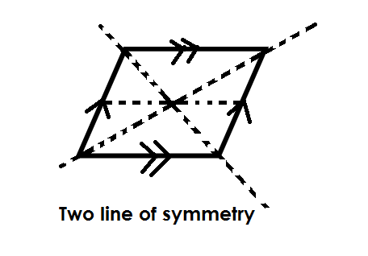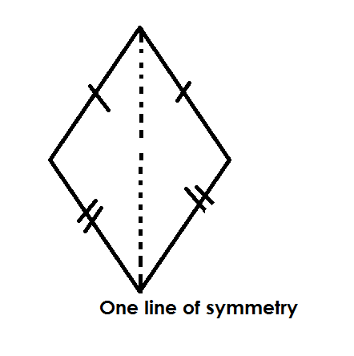(e) Kite (f) Rhiombus

(g) Parallelogram (h) Right Trapezium

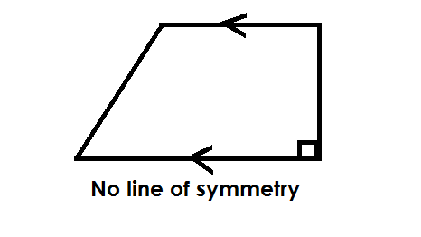

**No line of symmetry**

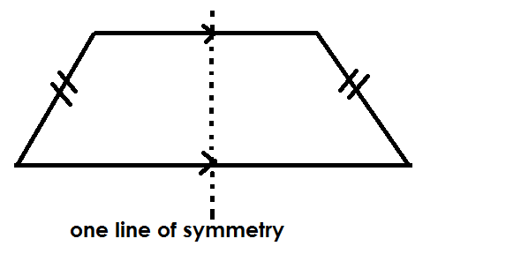(i) Isosceles trapezium

(k) Circle

Many lines of symmetry

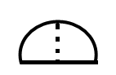(j) Semi circle

One line of symmetry

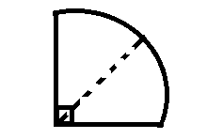(l) Quadrant

One line of symmetry

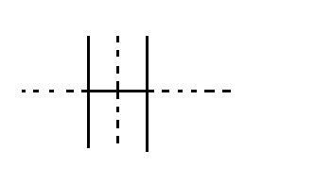**LINES OF FOLDING SYMMETRY IN LETTERS**

(1)

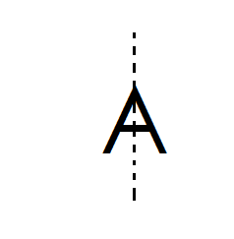 Two lines of symmetry

(2) One line of symmetry

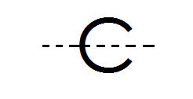

(3) One line of symmetry

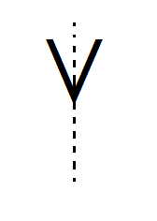

(4) One line of symmetry

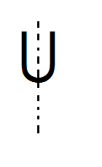(5) One line of symmetry

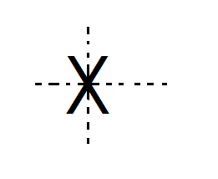(6) Two lines of symmetry

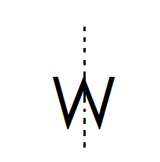

(7) One lines of symmetry

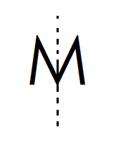

(8) One line of symmetry

**Note**:

All regular polygons have number of lines of symmetry that is equal to these number of sides.

**Name of regular polygon No. of lines of symmetry**

- Equilateral triangle 3

- Square 4

- Pentagon 5

- Hexagon 6

- Septagon 7

- Octagon 8

- Nonagon 9

- Decagon 10

- Nou-Decagon 11

- Duo decagon 12

**REVOLUTIONS / ROTATIONS / TURNS**

A revolution is a complete turn, i.e., a rotation from one point and back to the same point.

A complete revolution is made of 360**0**.

**Illustration**

3600

**FINDING PARTS OF A REVOLUTIONS.**

**Examples**

1. Find of a revolution.

1 revolution = 3600

1800

a revolution = x 3600

= 1800

**2.** What angle is of a revolution?

1 revolution = 360**0**

of a rev = x 360072**0**

= 1440

**Activity**

1. Find the angle that is of a revolution.

2. Which angle is of revolution?

3. Matama turned of a revolution which angle did he make?

4. How many degrees are in of a revolution?

5. Find of a revolution.

6. How many degrees can one make if he turns through of a revolution.

7. Find the angle that is a revolution.

**FINDING NUMBER OF REVOLUTIONS**

**Example I**

How many revolutions are in 7200?

**Soln**

3600 = 1 rev

2

1**0** = x 120

= 2 revolutions

**Example II**

Find number of revolutions in are in 540

**Soln**

3600  = 1 rev

1**0** = rev

63

5400 = x 540 Revolutions

4

2

= 1 rem 1

= 1 revolutions

**Activity**

1. Find number of revolutions in 10800 revolutions.

2. How many complete rotations are in 1800.

3. Find the number of revolutions in 9000.

4. How many revolutions are in 3600 revolution?

5. Calculate number of revolutions in 450.

6. How many revolutions are in 36**0**?

7. Find number of turns in 360**0**.

8. How many revolutions are in 3260**0**?

9. Find the number of turns in 3600**0**.

**ANGLES FORMED ON A COMPASS.**

A compass has two types of points i.e.

- Major cardinal points

- Minor / secondary cardinal points

**Major cardinal points**

- North (N)

- South (S)

- East (E)

- West (W)

**Illustration**

**North**

**West** **East**

**South**

**Minor cardinal points / secondary points**

* North East (NE)
* South East (SE)
* North West (NW)
* South West (SW)

**Illustration**









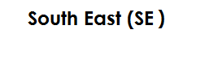



**Note**:

Since a complete revolution is equal to 360**0**,

45

1 sector = 360

8

= 450

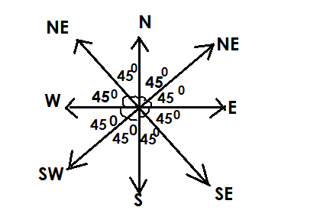**ANGLES BETWEEN COMPASS DIRECTIONS**

**Note**:

A smaller angle is the smallest sector between given points and largest angle is the largest sector between the two given points.

**Examples**

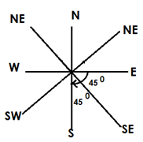What is the smallest angle between East and South?

I sector = 45**0**

2 sectors = 45 x 2

= 900

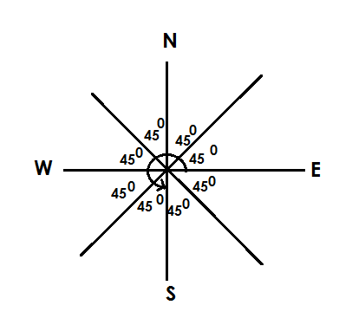Find the larger angle between East and South.

1 sector = 450

6 sectors = 6 x 450

= 2700

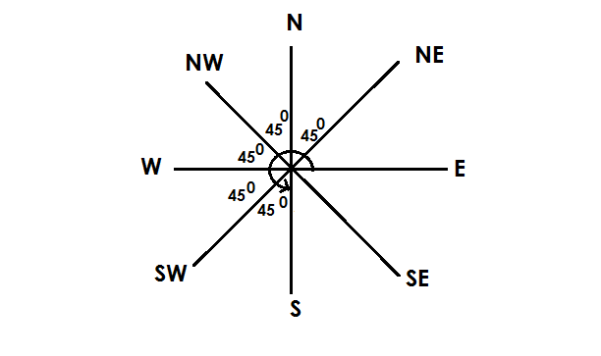What is the larger angle between South and North East?

1 sector = 450

5 sectors = 5 x 450

= 2250

**Activity**

1. Find the smaller angle between the following compass points.

(a) N and S.E

(b) NW and W

(c) NE and SW

(d) NW and NE

(e) E AND S

2. Find the larger angle between the following points.

(a) SE and W

(b) E and S

(c) N and NE

(d) NE and SW

(e) W and NW

**CLOCK WISE AND ANTI CLOCK WISE DIRECTION.**

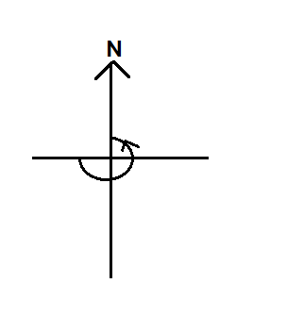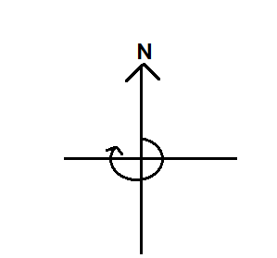Clock wise (right-hand turn) Anti clockwise (left-hand turn)

**FINDING DIRECTION GIVEN ANGLES**

**Examples**

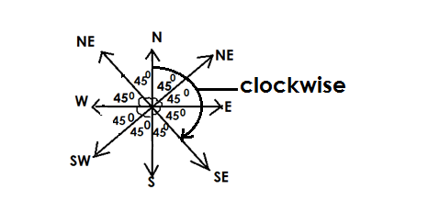Jane was facing North, she turned clockwise through and angle of 1350. In which direction did she face.

No. of sector =

= 3 sectors

She faced in South East

**Example II**

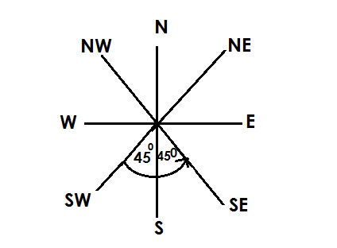Musa was facing in North West. He turned through an angle of 900anti wise. In which directions is he facing now?

No. of sectors = Angle given

450

= 900

450

2 sectors

He is facing in South East.

**Activity**

1. Alex was facing North East. He turned through an angle of 900 anticlockwise. Find his new direction.

2. A pilot was facing North on setting off, he turned through an angle of 1800clockwise in which direction did he take?

3. Wandella was facing in South West. He turned through an angle 1350 clockwise find his new direction.

4. Mukataza was facing in North West. If he turned through an angle of 225 anti clock wise. Find his new direction.

5. Find the direction Wakate will face if he turns through an angle of 3150 from North East clock wise.

**FINDING ANGLES WHEN GIVEN DIRECTION**

**Example I**

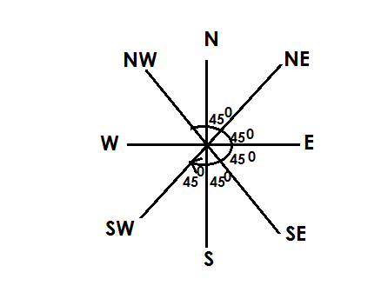A man was facing North. He turned clockwise to face South West. Find the angle turned.

1 sector = 450

5 sector = 5 x 45 0

= 2250

He turned through an angle of 2250

**Example II**

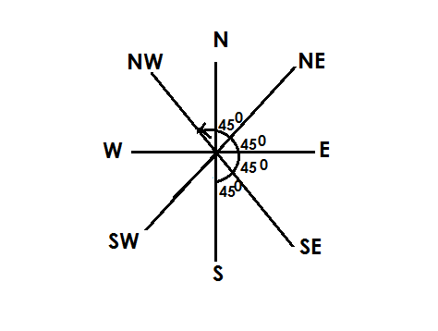Find the angle turned from South to North West anti clock wise.

1 sector = 450

5 sectors = 5 x 450

Therefore, the angle turned through is 2250

**Activity**

1. Through what angle can Okello from North to North East clockwise.

2. Find the angle that can be turned from North to South East anti clock wise.

3. What angle is made by a clockwise turn from South to North East?

4. James facing South East. He decided to turn anti clockwise to North. Through what angle did he turn?

5. Damali sat in class facing in South West If she was told to turn clockwise to face East, find the angle turned.

**CALCULATING MISSING ANGLES.**

(A) **COMPLEMENTARY ANGLES**

These are two angles that add upto 900 and originating from on point.

**Examples**

Given that 2m and 40° are complementary angles,find the value of m.

2m + 400 + = 900

2m + 400 – 400 = 900 – 400

2m =500

2m = 50025

2 2

m = 250

Given that k + 20° and 40° are complementary angles,find the value of k

K + 400 + 200 = 900

K + 600  = 900

K + 600 - 600 = 900 - 600

K = 300

**Activity**

1. Given that 2p and 60° are complementary angles,find the value of p.
2. Given that 2x and x are complementary angles,find the value of x
3. Given that p and 70° are complementary angles,find the value of p
4. Given that 3n and 36° are complementary angles,find the value of n.
5. Given that 4m and 5m are complementary angles,find the value of m.
6. Given that y + 10° and 60° are complementary angles,find the value of y.
7. Find the complement of 32°
8. Find the complement of 60°
9. The complement of k is 40°. Find the value of k
10. The complement of y + 27° is 30°. Find the value of y

**SUPPLEMENTARY ANGLES**

These are the two angles that add up to 1800 and originating from one point.

**Activity**

1. Given that 2p and 60° are supplementary angles,find the value of p.
2. Given that 2x and 3x are supplementary angles,find the value of x
3. Given that p and 70° are supplementary angles,find the value of p
4. Given that 3n and 30° are supplementary angles,find the value of n.
5. Given that 4m and 5m are supplementary angles,find the value of m.
6. Given that y + 10° and 60° are supplementary angles,find the value of y.
7. Find the supplement of 112°
8. Find the supplement of 60°
9. The supplement of k is 40°. Find the value of k
10. The supplement of y + 70° is 30°. Find the value of y

**INTERIOR ANGLE SUM O F TRIANGLES**

**Note**:

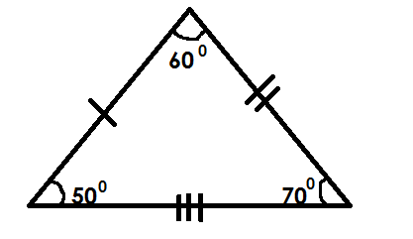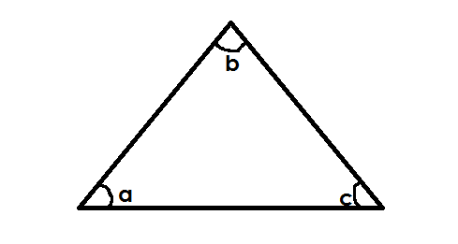A triangle has three interior angles which add upto 180**0**.



**TYPES OF TRIANGLES**

**A. Scalene triangle.**

**Note**: A scalene triangle has non of its sides and angles equal.

**Examples**

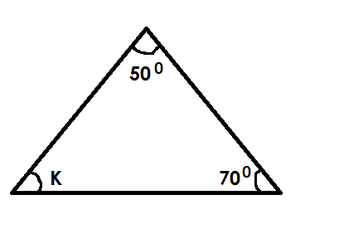1. Find the size of angle marked with letter K.

K + 500 + 700 = 1800

K + 1200 = 1800

K + 1200 - 1200 = 1800 – 1200

K = 600

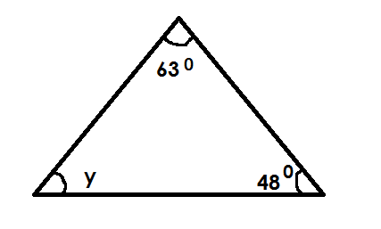2. Find the unknown angle in the triangle below

y + 630 + 480  = 1800

y + 1110 = 1800

y + 1110 - 1110 = 1800

y = 690

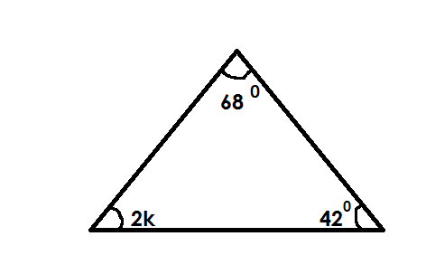3. Find the unknown angle in the figure below.

2K + 680 + 420 = 1800

2K + 1100 = 1800

2K + 1100 - 1110 = 1800 – 1100

2K = 700

2K = 700

2 = 2

K = 350

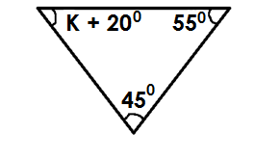4. Find the unknown angle in the triangle below.

K + 200 + 450 + 550= 1800

K + 1200  = 1800

K + 1200 – 1200 = 1800 – 1200

K = 600

**Activity**

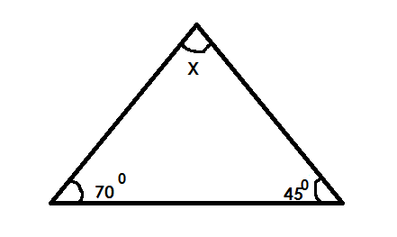1. Find the value of X in degrees.

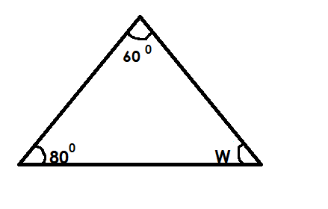2. Find the size of unknown angle.

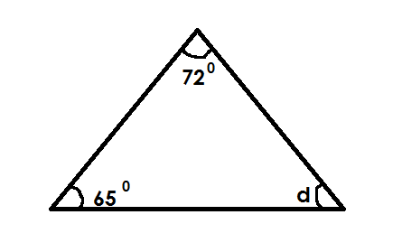3. Calculate the value of Y in degrees

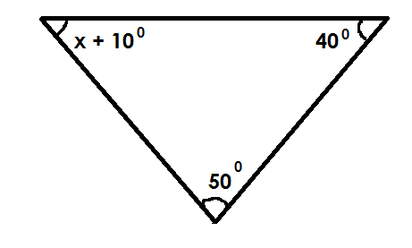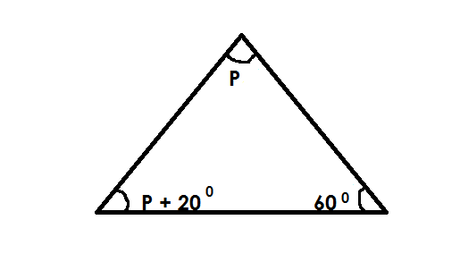4. Find the unknown angle in the triange below.

(a) (b)

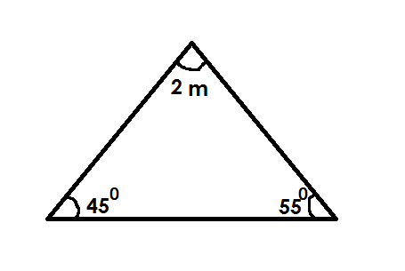(c)

**B. Equilateral triangle**

**Note**:

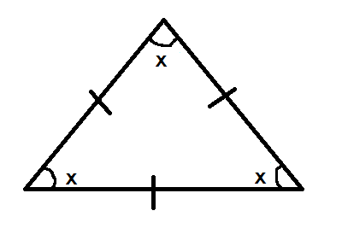All its three interior angles are equal



x + x + x = 1800

3x = 1800

3x = 1800

3 3

x = 600

Each interior angle of an equilateral triangle is equal to 600.

**Examples**

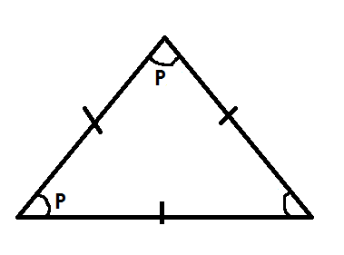1. Find the value of P in the figure below.

P + P = 1800

3p = 1800

3P = 1800

3 3

P = 600

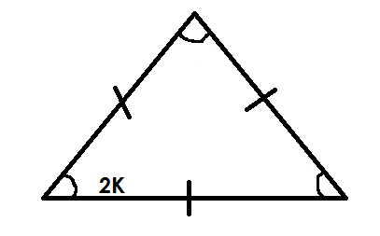2. Find the value of K in the triangle below.

2K + 2K + 2K = 1800

6K = 1800

6K = 1800

6 6

K = 300

**Activity**

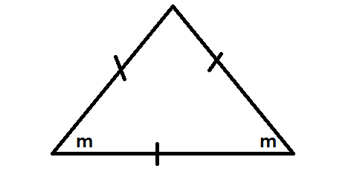1. Find the size of the unknown angle in each of the triangle below.

a.

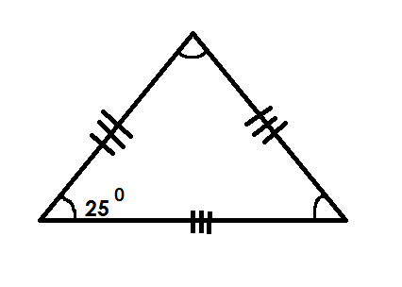

d.

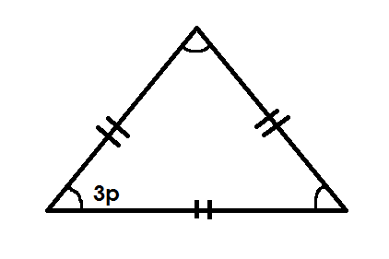

(c)

**C.** **Isosceles triangle.**

**Note**:

In an isosceles triangle, the two adjacent sides are equal making the two adjacent angles equal. (base angles are equal)

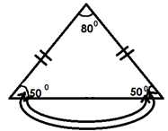Base angles are formed on the line that is different from others**.**

**Examples**

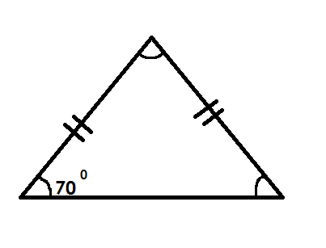1. Find the unknown angle in the figure below.

x + 700 + 700 = 1800

x + 1400 = 1800

x + 1400 - 1400 = 1800 - 1400

x = 400

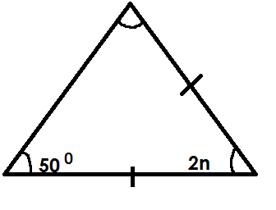2. Find the value of P in the triangle below.

2n + 500 + 500 = 1800

2n + 1100 = 1800

2n + 1100 - 1100 = 1800 – 1100

2n = 700

2n 2

n = 350

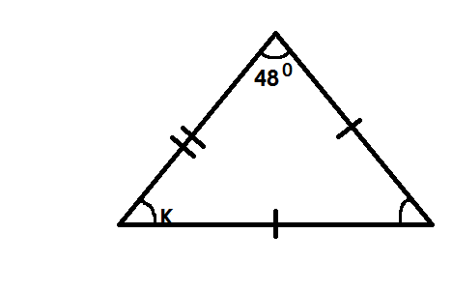3. Find the value of K in the figure below.

K + K + 480 = 1800

2K + 480 = 1800

2K + 480 + 480 = 1800 – 480

2K = 1320

2K = 1320

2 2

K = 600

**Activity**

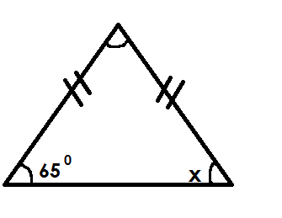1. Find the size of unknown angles in the triangles below.

(a)

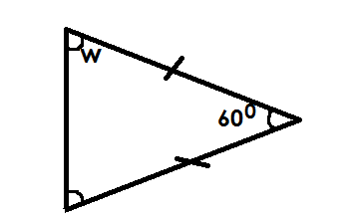(d)

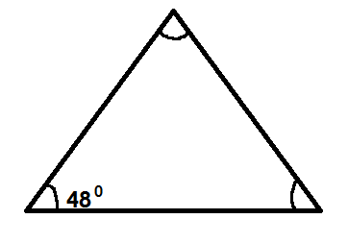

(b)

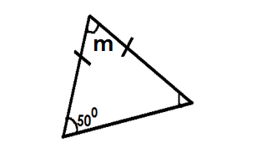

(e)

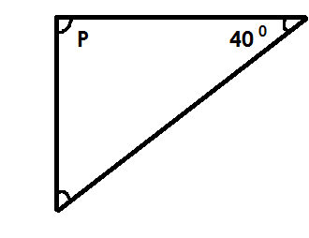(c)

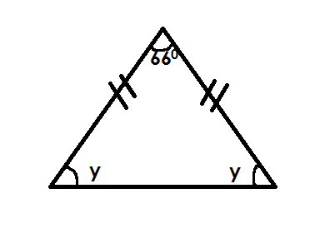(f)

**D.** **Right angled triangle.**

**Note**

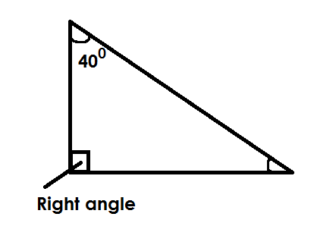In a right-angled triangle, one of its three interior angles measures 90**0** indicated by the symbol;

**Examples**

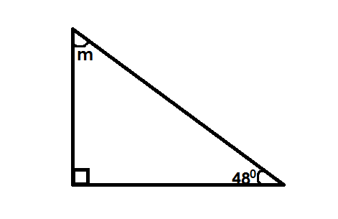1. Find the value of m in the figure below.

m + m 480 + 900 =1800

m + 1380 = 1800

m + 1380 – 1380 =1800 - 1380

m = 420

2. Find the unknown angle in the figure below.

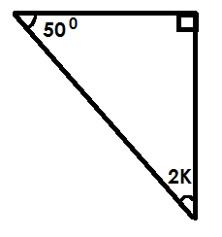 2K + 500 + 900 = 1800

2K + 1400 = 1800

2K + 1400 - 1400 = 1800 – 1400

2K = 400 20

2 2

K = 20

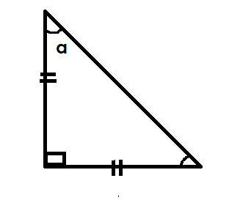3. Find the value of a in the figure below.

Soln

a + a + 900 = 1800

2a + 900 = 1800

2a + 900 - 900 = 1800

2a = 900

2 2

a = 450

**Activity**

1. Find the size of the unknown angle in degrees.

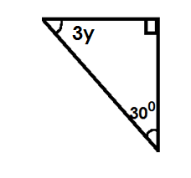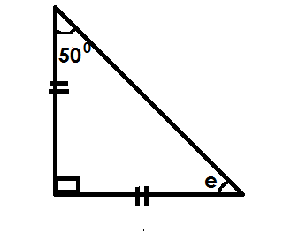(a) (d)

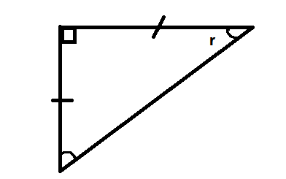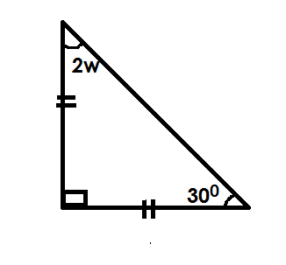

(b) (e)

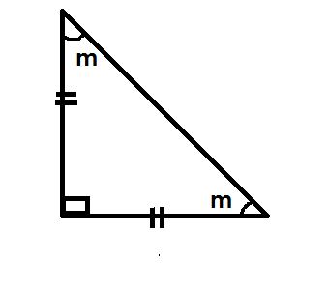(c) (f)

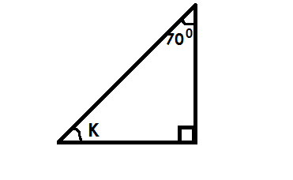

**DATA HANDLING**

**STATISTICS**

Statistics is a collection of information shown in numbers.

**Terms used**

Mode is the number that appears most in given data.

Range is the difference between the highest and the lowest number.

Median Is the middle number got after arranging in ascending order or descending order.

Modal frequency Is the number of times the mode appears.

Mean /average Mean is the uniform distribution of numbers, events, marks or scores.

**NB**  Mean or average is the result got after dividing the sum of items by their number.

**FINDING, MODE, RANGE, MEDIAN AND MEAN/AVERAGE AND MODAL FREQUENCY**

**Examples**

1. Given the list of numbers 1, 4, 6, 7, 8, 4

(a) Find the mode

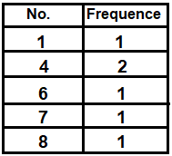 **Soln**

Mode = 4

(b) Find the range

**Soln**

Range = H – L

= 8 – 1

Range = 7

c. Work out the median

**Soln**

Median = 4 4 6 7 8

Median = 4 + 6

2

= 10

 2

Medium = 5

d. Find the mean

**Soln**

Mean = sum of items

No. of items

Mean = 1 + 4 + 4 + 6 + 7 + 8

6

Mean = 30

6

Mean = 5

(e) Find the modal frequency

No Frequency

1 1

4 2

6 1

7 1

8 1

The modal frequency = 2.

2. Richard scored the following marks in his end of term 1 examinations.

35, 50, 60, 45, 60

1. What was his range.

Range = Highest – lowest

= 60 – 35

Range = 25 marks

(b) Find his median mark.

Soln

Ascending

Median = 35 , 45 , 50 , 60 , 60

50

Median = 50 marks

c. Find the modal mark.

**Soln**

No frequency

35 1

45 1

50 1

60 2

The modal mark is 60.

d. Calculate his average mark.

Average = sum of items

No of items

Average = 250

5

Average = 50

e. Find the modal frequency

**Soln**

**No frequency**

35 1

45 1

50 1

60 2

The modal frequency is 2

**Activity**

1. Given the numbers 2, 4, 7, 2, 8 and 1.

(a) Find the mode

(b) Find the range.

(c) Calculate the median

(d) Workout the mean

2. Use the information below to answer question that follow.

3, 6, 7, 4, 5, 1, 4

a. Find the range

b. Workout the mode

c. Workout the mean

d. Find the average

e. Find the modal frequency

3. The boy scored the frequency marks in a test use them to answer questions.

5, 7, 2, 6, 10, 6

a. What is the highest mark?

b. Find the range.

c. What is the median mark?

d. Work out modal mark.

e. Find the mean.

Statistics is a collection of information shown in number.

**FINDING RANGE MODE MEDIAN AND MEAN OF GROUPED DATA**

**Example**

1. The table below shows marks scored by pupils in a test.

|  |  |  |  |  |
| --- | --- | --- | --- | --- |
| Marks scored | 40 | 50 | 30 | 60 |
| No. of pupils | 3 | 2 | 4 | 1 |

(a) How many pupils did the test?

3 + 2 + 4 + 1

= 10 pupils

(b) Find the modal mark

30

(c) Find the range of the mark.

Range = highest – lowest

= 60 - 30

= 30

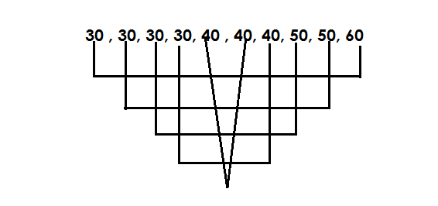(d) Find the median mark.

40 + 40

2

= 80

2

Median = 40

(c) Calculate the average mark

Average = Sum of items

No. of items

AV = (40 x 30) + (50 x 2) + (30 x 4) + (60 x 1)

10

AV = 120 + 100 + 120 + 60

10

AV = 400

10

AV = 40

**Activity**

1. The teacher recorded the weight of pupils as shown in the table below.

|  |  |  |  |  |
| --- | --- | --- | --- | --- |
| Weight in kg | 40 | 20 | 25 | 30 |
| No. of pupils | 1 | 3 | 2 | 4 |

(a) How many pupils were weighed?

(b) Find the modal weight.

(c) Find the range of the weight.

(d) Find the medium weight

(e) Calculate the mean weight.

2. Below is a table showing marks scored by pupils in at test.

|  |  |  |  |  |
| --- | --- | --- | --- | --- |
| Marks scored | 70 | 50 | 80 | 90 |
| Number of pupils | 2 | 3 | 4 | 1 |

(a) How many children did the test?

(b) Work out the modal mark.

(c) Find the range of marks.

(d) Work out the medium mark.

(e) Calculate the average mark.

3. The table below shows goals scored by different teams.

|  |  |  |  |  |  |
| --- | --- | --- | --- | --- | --- |
| Number of goals | 2 | 3 | 6 | 7 | 10 |
| Number of pupils | 4 | 1 | 2 | 1 | 2 |

(a) How many teams participated?

(b) Workout the modal score.

(c) Find the range of score.

(d) Find the median score.

(e) Work out the mean score.

**MORE ON FINDING RANGE, MODE, MEDIAN AND MEAN OF GROUPED DATA.**

**Examples**

Complete the table

|  |  |  |
| --- | --- | --- |
| Marks | No of pupils | Total |
| 40 | …………… | 120 |
| ………… | 4 | 80  …………. |
| 60 | 2 | …………. |
| ………… | 1 | 90 |

No of pupils = 120

40

= 30

Marks = 80

4

= 20

Total = 60 x 2

= 120

Marks 90

1

= 90

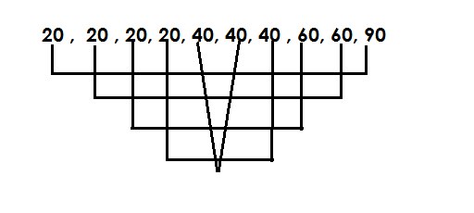b. Find the median mark

median = 80

2

Median = 40

Use the table below to answer questions that foolw.

|  |  |  |
| --- | --- | --- |
| Marks | No of pupils | Total |
| 80 | **IIII** | …………… |
| ………… | **IIIII** | 180 |
| 60 | …….. | 120 |
| ………… | **IIIIIII** | 160 |

a. Complete the above table

Total = 80 x 4

= 240

Marks = 180 30

60

= 30

Tallies = 120

60

= 2

Marks = 160 20

8

Marks = 20

(b) Find the median marks

Median =20, 20, 20, 20, 20, 20, 20, 20, 30, 30, 30, 30, 30, 30, 60, 60,

80, 80, 80, 80

Median = 30 + 30

2

Median = 60

2

Median = 30

c. Find the mean mark

Soln

Mean = Sum of item

No of items

Mean = (20 x 8) + (30 x 60) + (60 x 2) +( 80 x 4)

4 + 6 + 2 + 8

Mean = 780

20

= 39

**ACTIVITY**

1. Use the table below to answer the questions that follow.

|  |  |  |
| --- | --- | --- |
| Marks | No of pupils | Total |
| 80 | 2 | …….. |
| 40 | ……… | 120 |
| …….. | 1 | 50 |
| 70 | …….. | 280 |

(a) Complete the above table

(b) How many pupils are in the class.

(c) Find range of marks.

(d) Calculate the average mark.

(e) What is the median mark.

2. Use the table below to answer questions.

|  |  |  |
| --- | --- | --- |
| **Marks** | **No of pupils** | **Total** |
| 40 | **I I** | …….. |
| ……. | **IIII I** | 180 |
| 80 | ……. | 160 |
| …… | **I** | 90 |

(a) Complete the table

(b) Find the modal mark

(c) Calculate the range mark

**Graphs and interpretation of date**.

A graph is a picture or diagram used to show facts or numbers.

**Tallies**

Tallies are marks used to count and group things is five.

**Examples**

(a)  **1**

(b) **2**

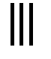

(c) **3**

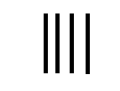

(d)  **4**

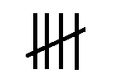

(e) **5**

(g) **12**



(f) **15**

**Activity**

1. Study and complete the tally marks below.

(a)

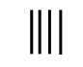(b)

(c)

(d)

(e)

(f)

(g)

(h)

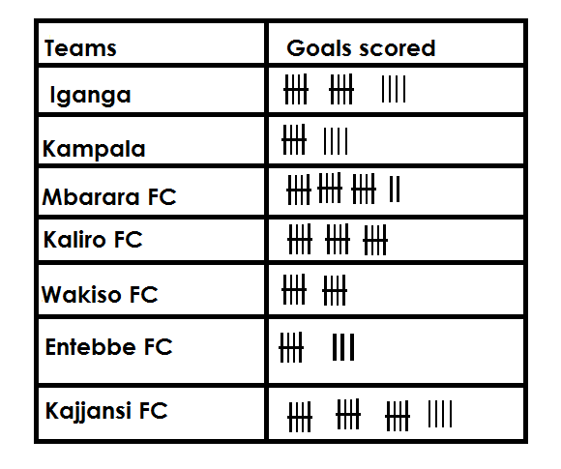2. The table below shows the number of goals scored by different teams. Use it to answer questions that follow.

a. How many goals did Iganga FC score?

b. Which team scored the highest number of goals?

c. How many goals were scored by Mbarara FC and Entebbe FC altogether?

d. Find the number of goals scored by Kampala FC, Kaliro FC.

e. Find the total number of goals scored by all teams.

3. Complete correctly

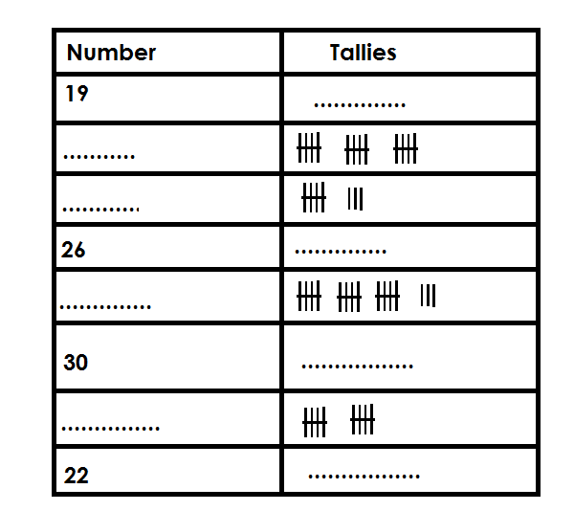

**SCALE INTERPRETATION**

 **Examples**

Given that represents 10 pupils find the number of pupils represented by



**Soln**

1 picture = 10

4 pic = (4 x 10) pupils

5

= x 10 pupils

 = 45 pupils

If represents 20 balls. Draw pictures to represents 70 balls.

**Soln**

20 balls = 1 picture.

1 ball = = pic

70 balls = x 70

= 3 rem 1

= 3



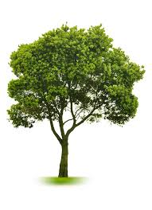 **Activity**

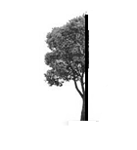1. If represents 50 trees. Find the number of trees represented by



2) Given that represents 20 books. How many books are represented by



3) Given that represents 40 oranges. Draw pictures to represent 200 oranges.

4) If represents 150 balls draw balls to represent 450 balls.

5) Given that represents 8 chairs draw pictures to represent 72 chairs.

**GRAPHS AND DATE HANDLING**

**Review: -**

- Interpretation of pictographs

- Drawing pictographs

**BARS GRAPHS**

This is a type of graphs were information / data is represented by use of columns and blocks.

**INTERPRETATION OF BAR GRAPHS**

**Example 1**

The graph below shows the attendance of pupils of primary five in a week.

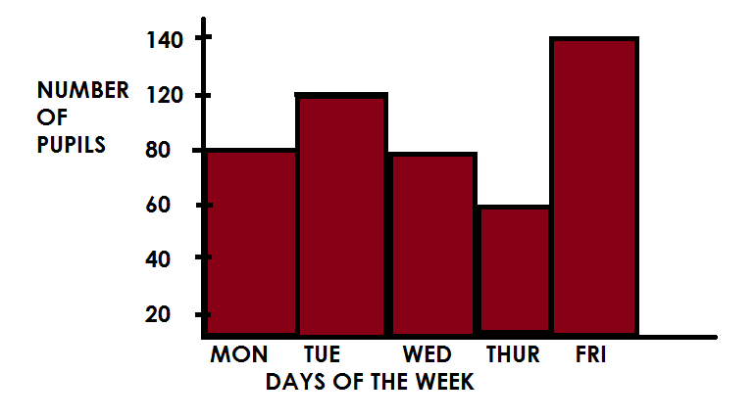

Vertical (A – axis)

Horizontal axis (x – axis)

**Note**:

While dealing with graphs, identify the vertical scale (axis) and the horizontal scale

(x – axis)

**A scale**

This is the quantity / number that is represented by one square.

-1 square one the vertical / axis represents 20 pupils.

-1 square on the horizontal axis represents one (1) day.

**Questions**

(a) On which day was the attendance height.

It was Friday.

(b) How many pupils were present on Tuesday?

120 pupils

(c) Which two days had the same attendance?

Monday and Wednesday

(d) How many pupils attended on Tuesday and Thursday?

Tue 1 2 0 pupils

Thur + 6 0 pupils

1 8 0 pupils

(e) Find the range in the attendance of pupils

Range = H - L

= 1 4 0 pupils

- 6 0 pupils

8 0 pupils

(f) Calculate the average attendance of pupils in the class.

Average = Sum of all items

No. of items

= 80 + 120 + 80 + 140

5

= 480 96

5

= 96 pupils

**Activity**

1. Study the graph and answer the questions below.

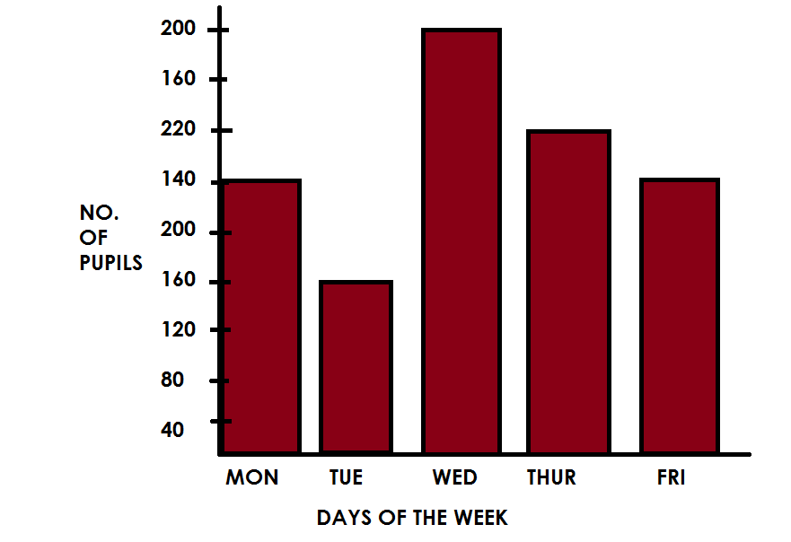

**Questions**

(a) State the vertical scale.

(b) What is the horizontal scale.

(c) How many pupils attended on Thursday?

(d) Find the total attendance of pupils on Monday and Friday.

(e) Which day had the lowest attendance?

(f) Identify the day that had the height attendance.

(g) Find the median attendance.

(h) Calculate the range in the attendance of pupils for the whole week.

(i) Work out the average attendance of pupils of the whole week.

2) The graph below shows number of eggs sold in a week.

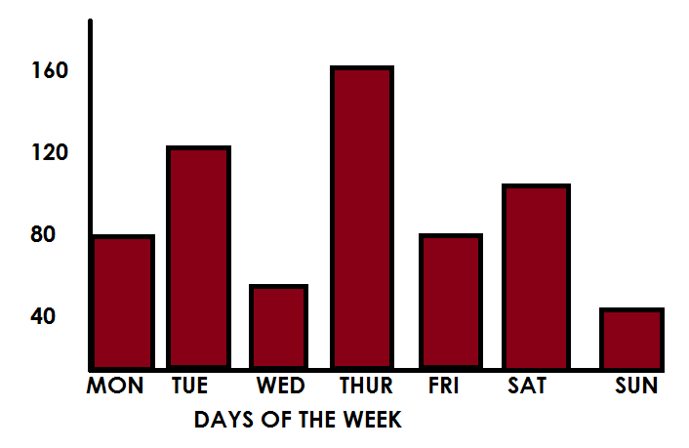

**Questions**

(a) How many eggs were sold on Wednesday?

(b) Which day had the height attendance?

(c) Identify the two days that had the same attendance.

(d) If eggs were packed on trays each 30 eggs, how many trays were produced on Monday and Sunday?

(e) Calculate the average number of eggs produced from Monday to Friday.

(f) Find the range in the production of eggs for whole week.

**DRAWING BARS GRAPHS**

- The graph should be well labeled.

- All graphs are drawn on a scale.

- If the scale is not given, come up with the vertical and horizontal scale before representing information on a bar graph.

- A good graph should have a title.

**Example I**

The table below shows types of food liked by pupils in P.5.

|  |  |  |  |  |  |
| --- | --- | --- | --- | --- | --- |
| No. of pupils | 10 | 15 | 5 | 20 | 25 |
| Types of food | Potatoes | Millet | Posho | Cassava | Rice |

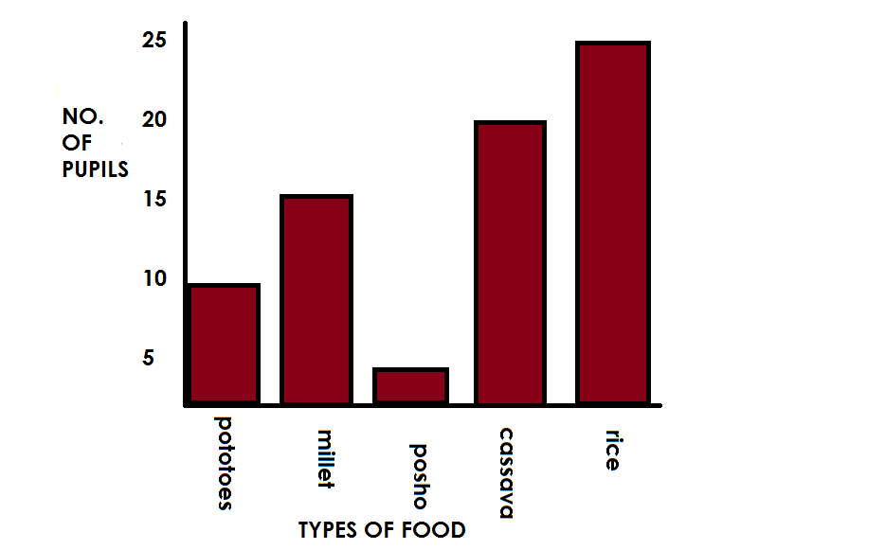

**Questions**

(a) How many pupils like rice?

(b) Find the range of pupils.

(c) How many pupils are in primary five?

(d) Calculate the average number of pupils.

**Activity**

The table below shows pupils of St. Anthony Primary School.

|  |  |  |  |  |  |
| --- | --- | --- | --- | --- | --- |
| No. of pupils | 40 | 100 | 40 | 80 | 60 |
| Class | P.1 | P.2 | P.3 | P.4 | P.5 |

Show the above information on the graph below.

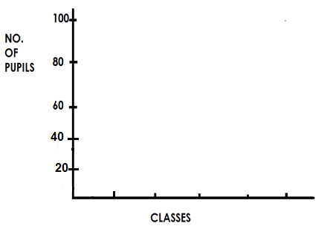

1. Which class has the highest number of pupils?
2. How many pupils are in P.1 and P.4?
3. Calculate the average number of pupils in the school.

2. The table below shows the average between rainfall at the Mt. Elgon between March and August. Study the table carefully.

|  |  |  |  |  |  |  |
| --- | --- | --- | --- | --- | --- | --- |
| Month | March | April | May | June | July | August |
| Rainfall | 30cm | 65cm | 50cm | 70cm | 80cm | 70cm |

1. Draw a bar line graph to represent the information in the table.
2. Choose a title for your graph.
3. What is the scale on your vertical axis?
4. What is shown on your horizontal axis?
5. What is shown on your vertical axis?

**LINE GRAPH**

Line graphs are often used to show how something changes over a period of time.

**Example I**

The following were numbers of correct answers scored in different subjects.

|  |  |
| --- | --- |
| **SUBJECTS** | **NUMBERS OF CORRECT ANSWERS** |
| English | 5 |
| Maths | 6 |
| SST | 9 |
| SCI | 6 |
| R.E. | 8 |
| Music | 10 |

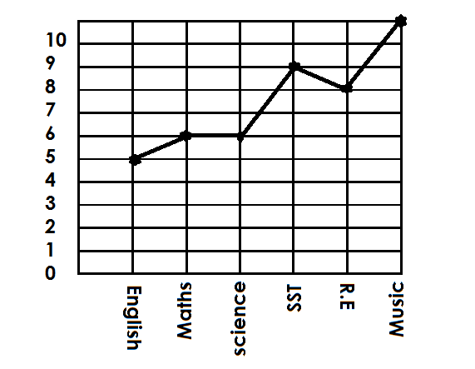Draw a line graph and represent the above data.

(a) What was Mukobe’s score in SST?

Mukobe scored 9 in SST.

(b) How many questions did Mukobe fail in Maths?

10 – 6 = 4 Mukobe failed 4 questions.

(c) In which subjects did Muobe have all answers correct?

Mukobe got all members correct in music.

(d) Workout Mukobe’s total score in all five subjects

= 5 + 6 + 6 + 9 + 8 + 1 0

= 4 4

**Activity.**

1. The table below shows marks scored by Alex in a test which was marked out of 10.

|  |  |
| --- | --- |
| **Subject** | **Marks scored.** |
| ENGLISH (ENG) | 8 |
| MATHEMATICS (MTC) | 10 |
| SCIENCE (SCI) | 4 |
| SOCIALSTUDIES (SST) | 6 |
| RELIGIOUS EDUCATION (R.E) | 5 |

Draw a line graph and represent the above information.

2. Below are different ages of pupils in P.3.

|  |  |
| --- | --- |
| **Pupils Name** | **Age** |
| Alex | 8 |
| Musa | 7 |
| Ali | 9 |
| Alice | 10 |
| Ruth | 8 |
| Faith | 8 |

Draw a line graph and represent the above data

3. Use the information below showing number of people in different families to draw a line graph.

|  |  |
| --- | --- |
| Family. | Number of people. |
| Kato’s family | 11 |
| Mubiru’s family | 8 |
| Ariho’s family. | 9 |
| Kiiza’s family. | 10 |

4. The table below shows Kasita’s daily sales for a week.

|  |  |  |  |  |  |  |
| --- | --- | --- | --- | --- | --- | --- |
| Day | Mon | Tue | Wed | Thur | Fri | Sat |
| Sales in (sh) | 20,000 | 15,000 | 25,000 | 30,000 | 40,000 | 35,000 |

(a) Draw a graph to show the information in the table.

(b) What is the difference between the highest and lowest sales?

(c) What is total value of sales for the six days?

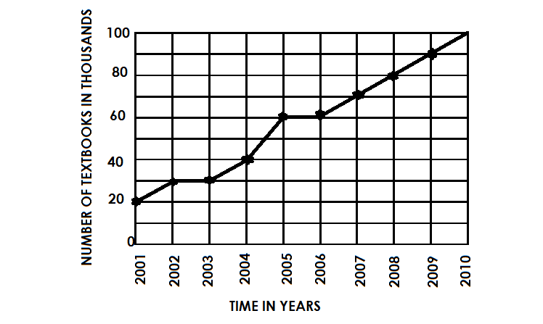5. The graph below shows text books received by primary schools in a district for ten years use it to answer questions that follow.

(a) In which year was the biggest number of text books received?

(b) How many text books were received in 2002?

(c) Calculate the total number of textbooks that were received in 2009 and 2000.

(d) Name the year in which 50,000 books were received.

(e) In which year was the least number of textbooks received?

**TIME**

**Telling time in a.m and p.m.**

* a.m mean Ante Meridiem.
* a.m is the first part of the day hence morning time.
* a.m starts from 12:00 mid – night to 12:00mid- day
* p.m means post meridiem.
* p.m is the second part of the day hence afternoon and evening time.

**Example**

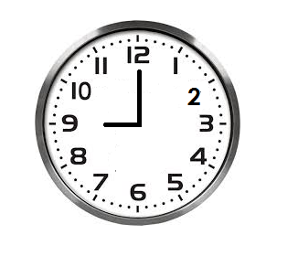(1) Write the time in a.m and p.m

9:00 a.m**or** 9:00p.m

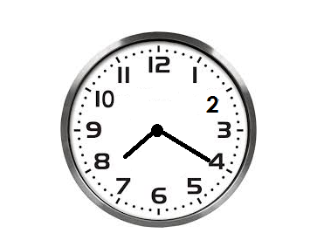(2) Write the meaning time on the clock face below.

8:20 a.m

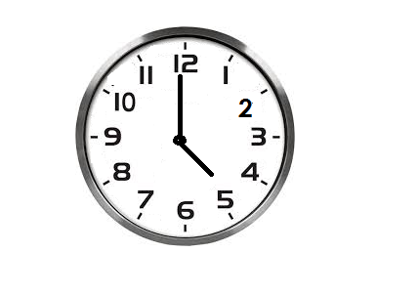(3) Write the morning time shown on the clock face below.

5: 50am

(4) Express 6 o’clock in the morning

Soln

6:00a.m

(5) 8 o’clock in the afternoon

Soln

8:00p.m

**Activity**

(1) Write the morning time shown on the face.

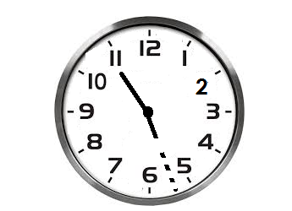

(2) Write the evening time shown on the clock face.

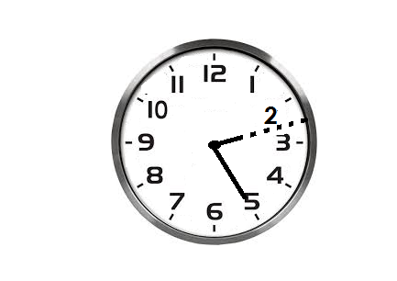(3) Write the morning time on the clock face.

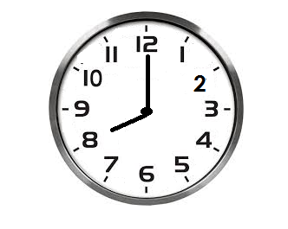

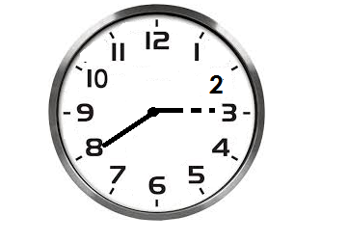(4) Write the afternoon time shown on the clock face.

(5) Write the time using a.m or p.m

(a) The time when the first lesson begins at 8 o’clock.

(b) The time when you go to sleep at 9 o’clock.

(c) The time when we go home at a half past 5 o’clock.

(d) What time is a quarter to 9 o’clock in the morning.

(e) The time when we go to school at a half past 6 o’clock in the evening.

**CHANGING HOURS TO MINUTES**

**Note**: **1 hour = 60 minutes**

**Examples.**

Change 4 hours to minutes

1 hour = 60minutes

4 hours = (4 x 60) minutes

= 240minutes

Covert 2to minutes

1 hour = 60minutes

2 hour =2 x 60 minutes

30

= x 60 minutes

= 150 minutes

Express 9 x 60mimutes

1 hour = 60minutes

9hours =9x60minutes

15

= 37 x 60 minutes

4

= 555 minutes

Convert 3hours to minutes.

**Soln**

1 hours = 60minutes

3hours =3x 60 minutes

15

= x 60 minutes

= 195 minutes

**Activity**

1. Convert 4 hours to minutes.

2. Convert the following hours to minutes

(a) 1 hours (b) 4 hours (c) 6 hours (d) 7 hours

(e) 9 hours (f) 10 hours (g) 13 hours

**CHANGING MINUTES TO HOURS**

**Note: 60minutes = 1 hour**

**Example**

1. Change 240 minutes to hours.

**Soln**

60 minutes = 1hr

1 min = hours

4

240 mins = x 240 hrs

= 4hrs

2. Change 150 minutes to hours

**Soln**

60mins = 1hrs = 555 hours

1 min = x 555 hrs 60

9 hrs

**Activity**

1. Change the following minutes into hours

(a) 120 minutes

(b) 360 minutes

(c) 210 minutes

(d) 135 minutes

2. The meeting lasted for 90 minutes. Express the time the meeting lasted in hours.

**ADDITION OF TIME**

**Note**:

We cannot have more than 59 minutes in the column of minutes.

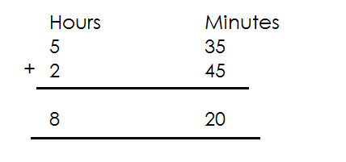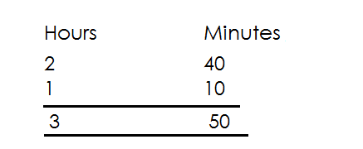 **Example**

1. Add: 2. Add:

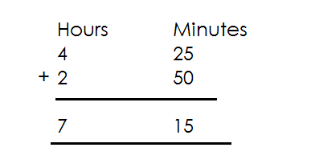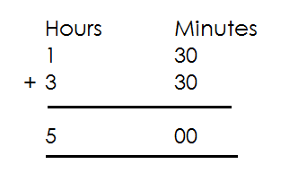

3. Work out: 4. Add:

**Activity**

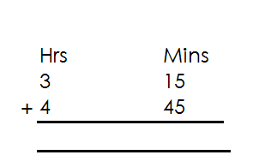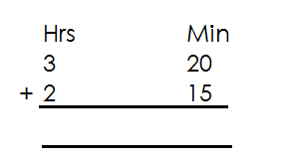1. Add the following

(a) (d)

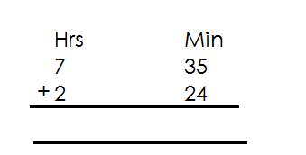

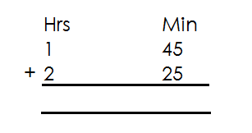(b) (e)

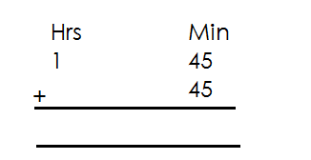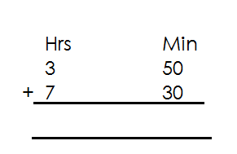

(c) (f)

2. Add 3hrs 35 minutes to 4 hrs 42 minutes.

3. Baguma walked for 2hrs 40minuted from his home to the river and for 1hr 50 minutes from the river to the market. How long did it take him to walk from home to the market?

**SUBTRACTION OF TIME**

**Note**:

When re-grouping in subtraction of hours and minutes, regroup 1 hour = 60 minutes.

Examples.

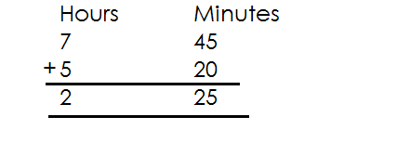1. Subtract:

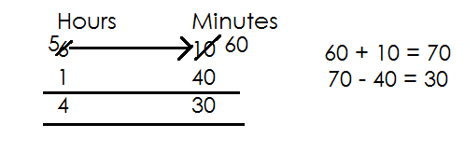2. Work out:

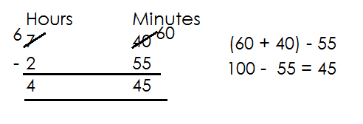

3. Subtract:

**Activity**

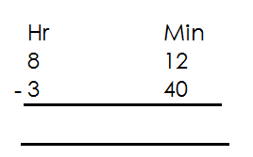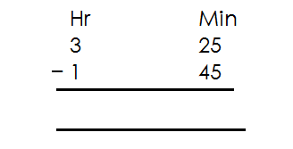1. Subtract the following

(a) (d)

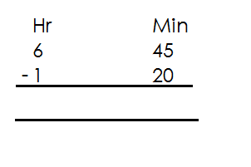

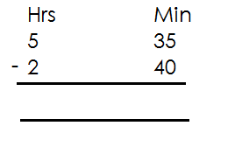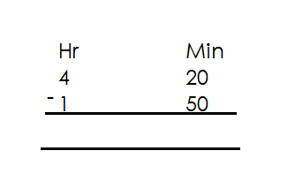(c) (e) (d)

2. Ben took 3 hrs 25 min to move from home to town. If he walked 1hour 35min and took a taxi for the rest of the journey. How much time did he spend in the taxi?

3. Anukunda spent a total of 5hrs 20 minutes at school. She played for 1 hr 30 minutes for how long did she stay in class?

**CHANGING TIME FROM 12 HOURS CLOCK TO 24 HOURS CLOCK.**

**Note**:

* Time in 24 hour clock system is determined in hours (don’t put a.m or p.m) .
* Dots separating hours and minutes are not written on time in 24-hour clock
* Time in 24-hour clock system is written using 4 digits.
* 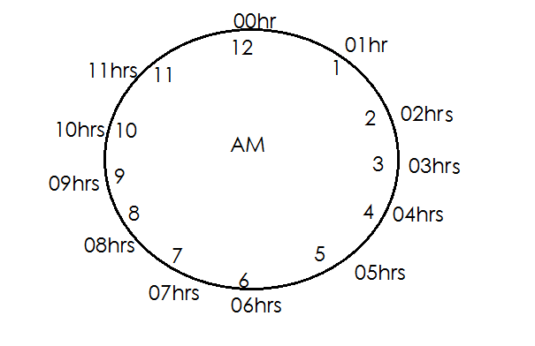Given AM, use AM clock face whose first hour in 24 is 00hrs.

1. 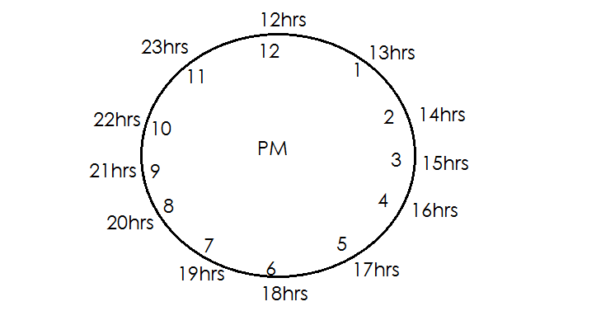Give pm, we use pm clock face whose first hr in 24hour is 12 hours.

- Minutes, in 12-hour clock system remain the same in 24-hour clock system.

**Examples**

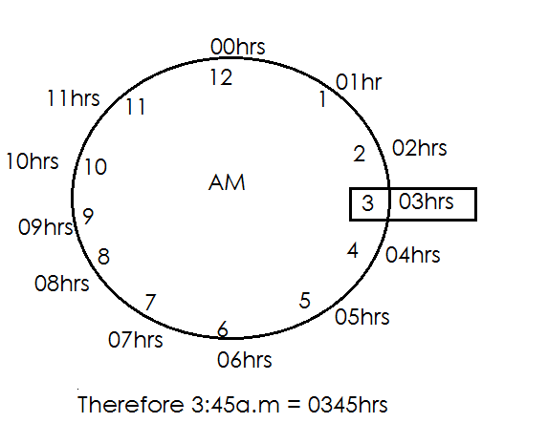1. Express 3:45a.m to a 24 hours clock system.

2. Write 12:00midnight in 24-hour clock system.

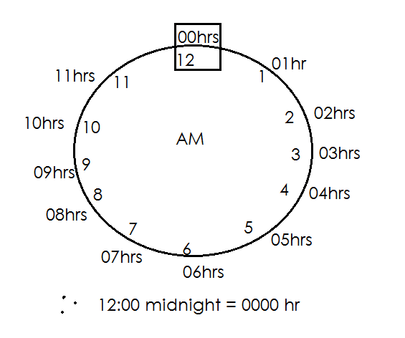

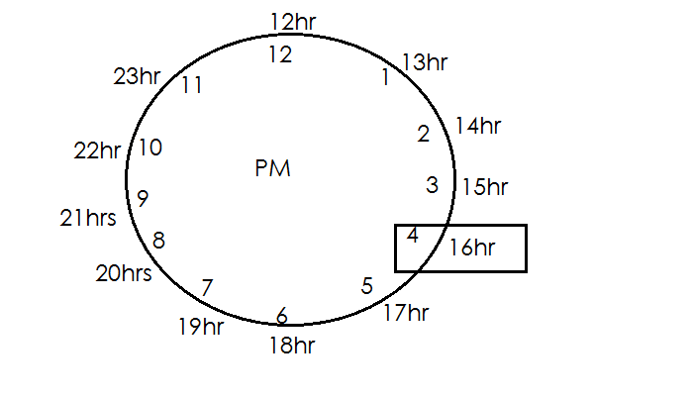3. Express 4:35pm to 24hr clock system.

There 4:35 pm = 1635 hr.

**Activities**

1. Express 2:30pm to 24-hour clock system.

2. Change 3:20am to a 24-hour clock system.

3. Convert 4:25pm to a 24-hour clock system.

4. Convert the following to the 24-hour clock

(a) 11:28pm

(b) 11:00am

(c) 9:30am

(d) 8:25pm

(e) 2:35am

(f) 7:42am

**CHANGING 24 HOURS CLOCK SYSTEM TO 12 HOUR CLOCK SYSTEM**

**Note**:

* When the 24-hour time is below 12 hours, that time is in am part of the day.
* When the 24-hour time is 12 hours and above, that time is pm.

**Examples**

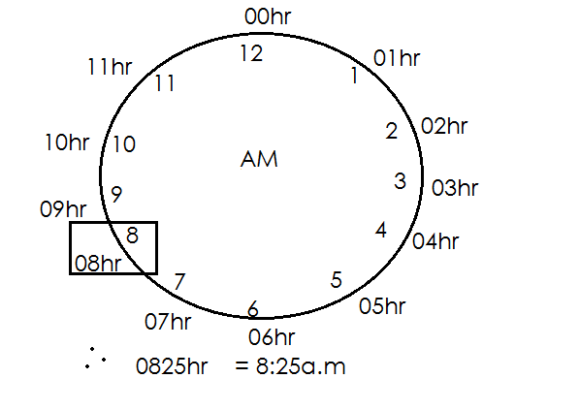1. Change 085hr into 12-hour clock system

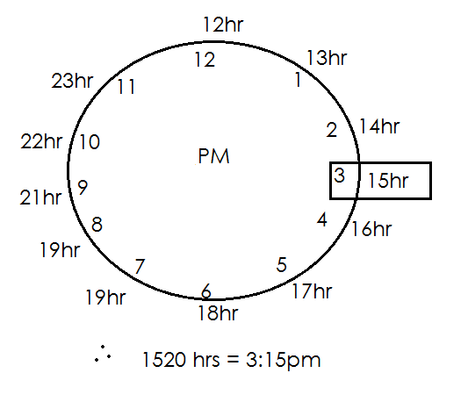2. Express 1520hr in 12-hour clock system.

**Activity**

Convert the following from 24 hours clock system to 12-hour clock system.

1. 1210 hrs 5. 1612hrs

2. 2100hrs 6. 1400hrs

3. 1745hrs 7. 2315hrs

4. 1330hrs

**FINDING DURATION**

Duration is the length of time something lasts.

**Or**

Duration is the time taken or used.

**Note**:

Duration = Ending time - starting time

Duration = ET - ST

**Examples**

A staff meeting started at 9:15a.m and ended at 11:45a.m. How long did it last?

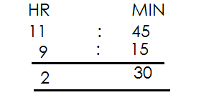 Duration = ET - ST

Ending time

Starting time

Duration =

The meeting lasted for 2 hours 30 minutes

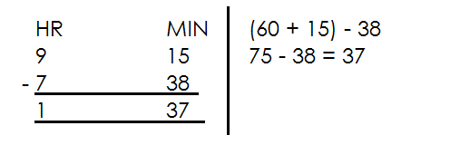2. Tony started walking from his home at 7:30am and reaches town at 9:15a.m. How long was his journey?

The jouney lasted for 1hour 37 minutes.

3. Tom started an examination at 2:30pm and ended at4:30pm. How long did he take?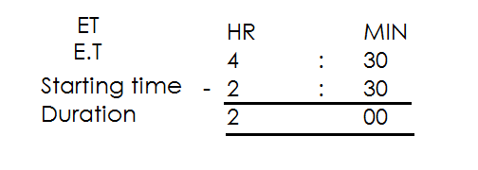

He took 2 hours

4. Jovan left Kampal for Nairobi at 6:00a.m and arrived in Nairobi at 8:20pm. How long did the journey take?

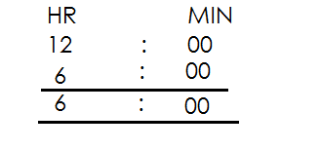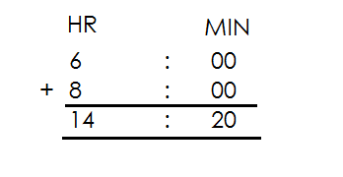 From 6:00am - Mid day (12:00) Then add



**Activity**

1. A foot ball match started at 5:00pm and ended at6:50pm. How long did it last?

2. A party started at 10:30am and ended at 3:00pm. How long did the part take?

3. Kasule left Kampala for Kasese at 4:12a.m and arrived at 12:00noon. Find the time the journey lasted.

4. A lesson started at 8:00a.m and ended at 9:30a.m. How long did it take?

5. My father went to the garden at 7:40am and came back at 11:00a.m. He long did he take?

6. A speech day started at 8:15am and ended at 5:00p.m. How long was the speech day?

**FINDING STARTING TIME A VENN ENDING TIME AND DURATION**

Starting time = Ending time - Duration

S.T = E.T – D

**Examples**

A 2 hours meeting ended at 10:00a.m. At what time did it start?

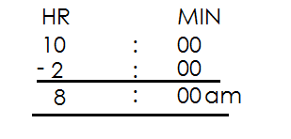 ST = E.T - D

The lesson started at 8:00a.m

A forty minutes lesson ended at 11:20a.m. At what time did start?

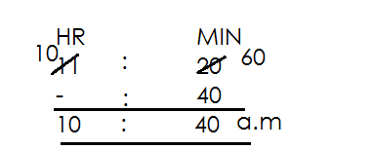Soln = E.T - D

The lesson started at 10:40a.m

**Example III**

Our baby wake up at 11:00a.m.He took 1sleeping. At what time did it start sleeping? 30

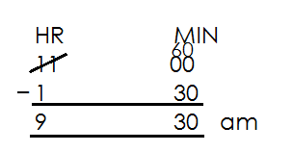**Soln** 1 hr x 60

E.T =

D = 1 hr 30min

The baby started sleeping at 9:30a.m

**Activity**

1. A maths lesson which ended at 9:30am lasted for 2 hours. At what time did it started?

2. A fifty minutes lesson ended at 11:50am. At what time did it start?

3. A football match ended at 11:0pm if it lasted for 1 hr 30minutes. At what time did it start?

4. Bobi’s speed speech lasted for 2hours 30min. If it ended at 11:50a.m. At what time did it start?

5. Richard sung for 40minutes. If he stopped at 9:20a.m. At what time did he start singing?

**FINDING ENDING TIME WHEN GIVEN STARTING TIME AND DURATIONS**

Ending time = Starting time + Duration

E.T = S.T + D

**Example**s

A lesson started at 8:00am and took 1 hours. At what time did it end?

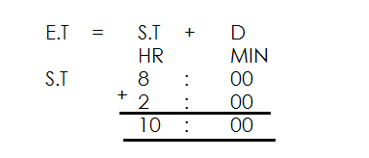

It ended at 10:00am

**Example II**

A farmer who started digging at 7:20a.m used 3 hours. At what time did he end?

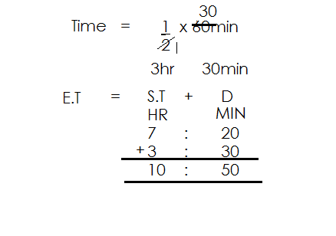**Soln**

He ended at 10:50am

**Activity**

1. A morning lesson started at 8:00a.m it took 2 hours. At what time did the lesson end?

2. A footbale match started at 3:30pm. If it took 1 . At what time did it end?

3. A church service took 3 hours. It started at 4:30p.m. At what time did it end?

4. At what time did the shoe end it it started at 4:00pm and took 3 hours?

5. Our baby woke up at 11:00a.m. He took 1 hours sleeping. At what time did he start sleeping?

**FINDING DISTANCE USING TIME AND SPEED**

**Note**:

- Distance is a numerical measurement for how far apart objects or points are.

- Speed is the rate at which distance is covered.

Distance = Speed x Time

Therefore Distance = S X T

**Examples**

Find the distance a driver covers in 2 hrs at a speed of 90km/hr

Distance = S x T

= 90km x 2hr

1hr

= 90km x 2

= 180km

A taxi takes 1 hrs to cover a distance from Kampala to Mufuta at a speed of 60km/hr. Find the distance between Kampala and Mufuta.

Distance = S X T

= 60km x 1hr

= 3 60km x hr

1hr

= 30km x 3

= 90km

Find distance covered by a bus that travels at a speed of 12okm / hr in 40min.

Distance = S X T change minutes to hours by

2 dividing given minutes by 40 min

= 120 x 40hr

1 hr 60

= 80km

**Activity**

1. A car moved at a speed of 50km/h for 3hrs. Find distance covered.

2. Find the distance covered by a cyclist moving at 15km/hr in 4hrs.

3. A motorist travelled from town A to B at a speed of 80km/hr in 2 hrs find the distance covered.

4. A school truck travelled for 2 hrs at an average speed 60km per hours. What distance did it cover?

5. A cyclist travelled for 3 hours at a speed of 80km/hr. Find distance covered.

6. A car travelled for 4 hr at an average speed of 84km/hr. How long was the journey?

7. A car moving at 120km/hr take 20min to cover a journey. How long is the journey?

8. Musa takes 40min to covers a distance at a speed of 60km/hr. Find the speed used.

9. At a speed of 48km/hrMatama takes 45min to cover the journry, how long is the journey?

**MORE ABOUT DISTANCE**

**Example I**

A taxi left Jinja at 8:00am travelling to Kampala at a speed of 60km/hr. If it reached at 10:00am. Find the distance covered.

**Soln**

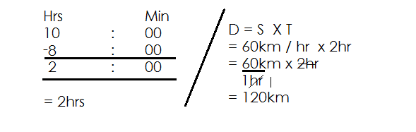 Time taken = ET - ST

**Activity**

1. A car moves at a speed of 80km/hr from 2:00pm to 4:00pm. Find the distance covered.

2. Find the distance coverd by taxi travelling at an average speed of 90km/hr from 1:00pm to 4:00pm.

3. A bus moves at a speed of 70km/hr from 8:15am to 11:15am. Find the distance covered.

4. At a speed of 54km/hracylist left Katongo at 9:00am and arrived at Kampala at 10:30am. How far is Kampala from Katonga?

5. A cylist left Kampala at 11:00am and arrive Masaka at 1:00pm moving at a speed of 70km/hr. Calculate the distance covered.

**FINDING TIME GIVEN DISTANCE AND SPEED.**

**Note:** Time = Distance ÷ Speed

= D ÷ S

Time is measured in hours, minutes or seconds.

**Examples**

How long will a car take to cover a distance of 120km at a speed of 40km/hr.

T = D ÷S 3

= 120km ÷ 40km/hr = 120km x 1hr

= 120km ÷ 40km 40km

1hr = 3hrs

A motorist covered a distance of 90km a speed of 60km/hr. Find time used.

 Time = D ÷ S

= 90km ÷ 60km/hr = hr

= 90km ÷ 60km

 1hr = 1 hr

= 90km x 1hr

60 km

2

**Activity**

1. Peter has to cover a journey of 240km at a speed of 80km per hour. Find time taken.

2. Find time needed to cover a journey of 180km at a speed of 60km.

3. Calcualte time required for a car to cover a distance of 120km at a speed of

60km /hr.

4. Acyclistcoverd a distance of 100km ate a speed of 40km/hr. how many did he take?

5. How long will it take acyclist did he a distance of 80km at a speed of 20km/hr.

6. If a bus moves at 30km/hr and covers a distance of 240km, how long does it take to cover the journey?

7. A taxi travelled at a speed of 70km/hr to cover a distance of 245km. How long did it take?

**FINDING SPEED GIVEN DISTANCE AND TIME**

Speed = D ÷ T Speed = D if given whole numbers

Speed is measure in T

km/hr or m/sec

**Examples**

Find speed used to cover a distance of 150km is 5hrs.

**Soln**

Speed = D

T

3

= 150

5hrs

= 30km/hr

A car covered a distance of 90km in 1 hrs. Calcualte the speed used.

Speed = D ÷ T

= 90km ÷ 1 hr

= 90km ÷ hr

= 90kkm x hr

= 30km x

= 60km/hr

At what speed did the bus travel to cover a distance of 80km in 40 minutes.

S = D ÷ T

 = 80km ÷ hr

= 80km x hr

= 120km/hr

**Activity**

1. Find the speed needed for a motorist to cover a distance of 360km in 3hrs.

2. A driver covered a distance of 200km in 2hrs. At what speed was he travelling?

3. A cyclist covered a journey of 84km in 4 hrs. At what sped was he travelling?

4. Find speed used to cover a distance of 60km in 2 hr.

5. An athlethic covered a distance of 12km in 1 hr find his speed.

6. A car covered 60km inhours. How many km did it cover in eachhour?

7. Martha spends 6hours on the way from Mbale to Kampala a distance of 420km. At what speed was she travelling?

8. Find speed needed to cover a distance of 30km in 20 minutes.

9. Calculate speed used to cover a distance of 120km in 50 minutes.

10. Othieno covered a distance of 180km in 40 minutes. Calculate his speed in km/hr.